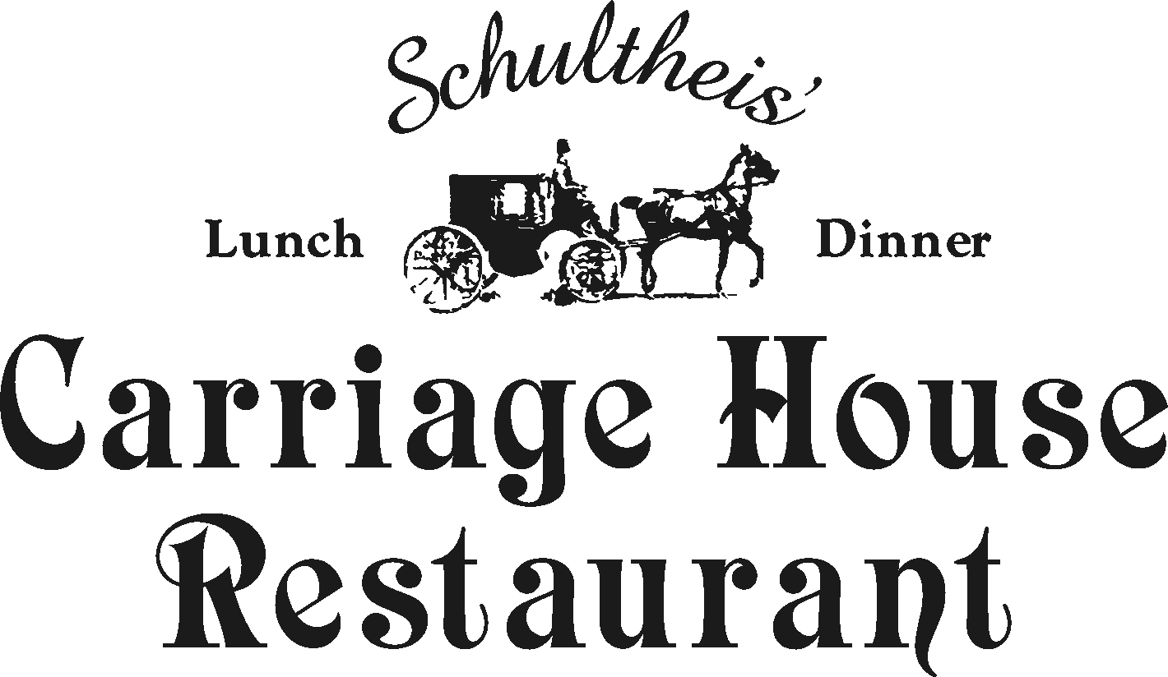

2017

The Carriage House
is the perfect venue for the
romantic wedding you have always dreamed of!

The Carriage House can accommodate wedding receptions up to 116 persons in our inside Main Dining Room and 140 persons in our
beautiful weather-proof Garden Terrace.

We offer “Sit down” or “Buffet Style” for 49.95 per person
all inclusive wedding package which includes your choice of
three entrees, house salad, fresh vegetable, potato, & fresh bread.
The package also includes your personalized wedding cake,
coffee & tea, & your choice of linen napkin color &
Unlimited Soda Bar
No need for a wedding planner, with the help of our friendly staff,
planning that perfect day will be fun and effortless!
Ask about our in-house florist, photographer,
and excellent entertainment contacts!
Thinking of having the Ceremony here?

Give us a call or stop by to see the beautifully landscaped grounds.
We will assist you in planning your Perfect Day!
~~~~~~~~~~~~~~
Located on Route 29 between Routes 663 and Routes 100
Conveniently located minutes from the turnpike

Circa 1745

Filet Mignon  8 oz Filet Broiled to perfection in a Cabernet wine sauce | Penne Della Casa  Fresh garden vegetables sautéed in a roasted tomato basil sauce over penne pasta
Chicken Adige  Sautéed chicken breast topped with sliced tomatoes, fresh baby mozzarella cheese in a white wine sauce | Sautéed Pork Filet  Sautéed boneless pork medallions, sliced apples,  shallots in a demi-glace and applejack brandy
Jaeger Chicken  Sautéed chicken breast in a classic hunter sauce: tomatoes, onions, forest mushrooms, tarragon, bacon in a brandy demi-glace | Beef Burgundy  Tender braised filet beef tips sautéed red wine & mushroom sauce over home-made spaetzles
Chicken Valdostano  Chicken sautéed then topped with black forest ham, Fontina cheese, almonds in a white wine demi-glace | New York Strip Steak  10 oz Strip Served in a rich peppercorn demi-glace topped with crisp Tyrolean onions
Chicken ala Rosa  Sautéed chicken & penne pasta tossed in a roasted tomato basil sauce then topped with freshly shaved Romano cheese and a touch of cream | Broiled Stuffed Flounder  Broiled flounder stuffed with jumbo lump crab meat  in a beurre blanc
Broiled Haddock  Broiled filet with a fine herb crust served in a light butter sauce | Veal Picante  Sautéed medallions of veal in a lemon butter and white wine sauce
Baked Salmon  Salmon filet wrapped in a pastry with asparagus, lump crab meat in a beurre blanc sauce | Veal Madeira  Sautéed medallions of veal with oyster mushrooms in a Madeira wine sauce
Fresh Catch of the Day…market value  May add crab meat or Lobster Tail to any entrée | Wiener Schnitzel  Sautéed breaded veal cutlet in white wine, capers, & browned butter sauce
Shrimp Provencale  Sautéed gulf shrimp with cherry tomatoes, fresh basil, garlic & olive oil over cappelini pasta | Prime Rib Au Jus  10 oz Prime Rib served in natural Au Jus with a horseradish cream sauce
Choose Three Dinner Entrees
Chicken, Seafood, Meat, Pasta

Hors'doeuvres Packages

Choose

Package #1 Choose 6………………………$6.50 per person
Bruschetta
Mini-ham and cheese Stromboli
Chicken tenders with dipping sauce
Assorted Puff Pastry
Cheese & fresh fruit (in season)
Grilled Vegetable Crudités’

Package # 2 Choose 6……………………… $8.50 per person
Bruschetta
Stuffed mushrooms
Brie and fruit sauce
Coconut shrimp
Skewered beef/marinated with teriyaki sauce
Scallops Wrapped in bacon

(Additional list of appetizers available upon Request )
You may personalize your own selection of delicious choices!
~~~~~

Raw Bar available Market Price
Shrimp cocktail, Clams on the half shell, Oysters and Crab claws

2017 Wedding Bar Packages

We offer a 4 hour reception
Option permitted to close bar during dinner

Open Well Service Package…………...$22 per person
Call brand liquors, Mixed drinks, Beer, wine, & soda

Open Beer & Wine Package………….. $20 per person
Beer & wine (Merlot, Cabernet Sauvignon, White Zinfandel, Pinot Grigio,
Chardonnay, & Riesling), & soda

Open Soda Package…………………... No Extra Charge
Soda, juice & Lemonade, Iced Tea, Unlimited
Included in the Wedding Package!

* Extend your reception 1 hour by closing the bar during dinner

LIQUOR LIABILITY— GUESTS MUST BE OF THE LEGAL AGE 21 TO CONSUME ALCOHOLIC BEVERAGES. ALL ALCOHOL MUST BE SERVED BY EMPLOYEES. WE RESERVE THE LEGAL RIGHT TO REFUSE FURTHER SERVICE TO ANY GUEST WHO IS VISIBLY INTOXICATED.
ALL ALCOHOL CONSUMPTION IS RESTRICTED TO THE EVENT SITE ONLY. We have a “no shot” policy. No exceptions.

~~~~~~~~~~~~~~~~~

Included in Your Wedding Package:
Dinner 48 pp
(Three entrees,
Fresh vegetable, potato, salad, fresh bread)
Personalized Wedding Cake
Coffee and Tea
Choice of Linen Napkin Color

Optional Menu Additions:
Appetizers $6.50 - $8.50 pp.
(Additional list of appetizers available upon Request)
Champagne Toast 3.50 pp
4 Hour Liquor Packages $20 - $22.
Dry Wedding: Cash Bar / Set up $250.00
(Fee not charged with Selected Liquor Package)

Your Personalized Wedding Cake

We are able to work with your picture
Or you may pick from our selection
~~~~
Dessert Table Option also Available
$6.50 per person
Miniature pastries,
cream puffs, cannolis, etc. & much, much, more
~~~~
Cakes brought in are subject to a
cake cutting charge

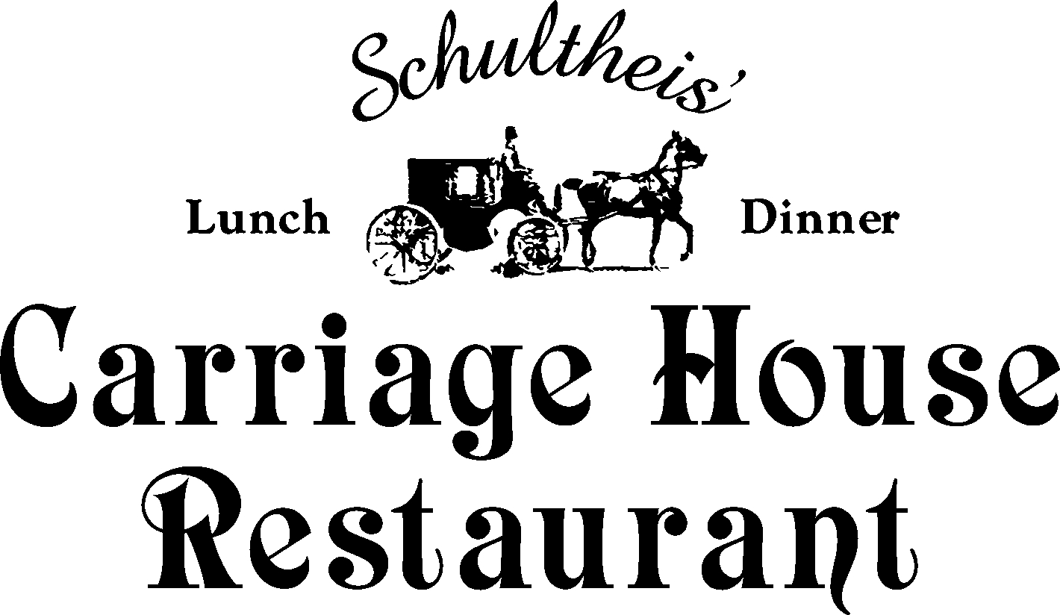

Your Personalized Wedding Cake

We are able to work with your picture
Or you may pick from our selection
~~~~
Dessert Table Option also Available
$6.50 per person
Miniature pastries,
cream puffs, cannolis, etc. & much, much, more
~~~~
Cakes brought in are subject to a
cake cutting charge

Your Personalized Wedding Cake included in Pricing
Up to Three Layers (Stacked or Tiered)
flavors included in Package:
chocolate, vanilla, marble, ½ and ½

~~~~~~~~
add fresh strawberry filling, Raspberry, apple, lemon, blueberry, Bavarian cream, chocolate, peanut butter, coconut, or banana cream
$1.00 extra per person

Frostings available are Butter Cream or Satin whip

We allow cake tasting up to three flavors
Samples can be obtained by appointment only

215-679-7700

Thank you for considering Our Restaurant for your special get together.
We will do every thing we can to ensure that it is a success!

~~~~~~
We have an excellent in-house florist who will assist
You with your floral ideas
Standard Ivory or White linens provided with
Your choice of napkin color

Tables are 54” Rounds seating for 8 inside
Head table may not exceed 10 persons inside
~~~~~~~~
60” rounds tables for 10 persons or 72’’ Rounds tables for 12
Persons ample seating for outside area

Skirting for head table, gift table, cake table, chair covers
available to rent

Specialty linens available to rent
based upon selection and size and color
~~~~~~~

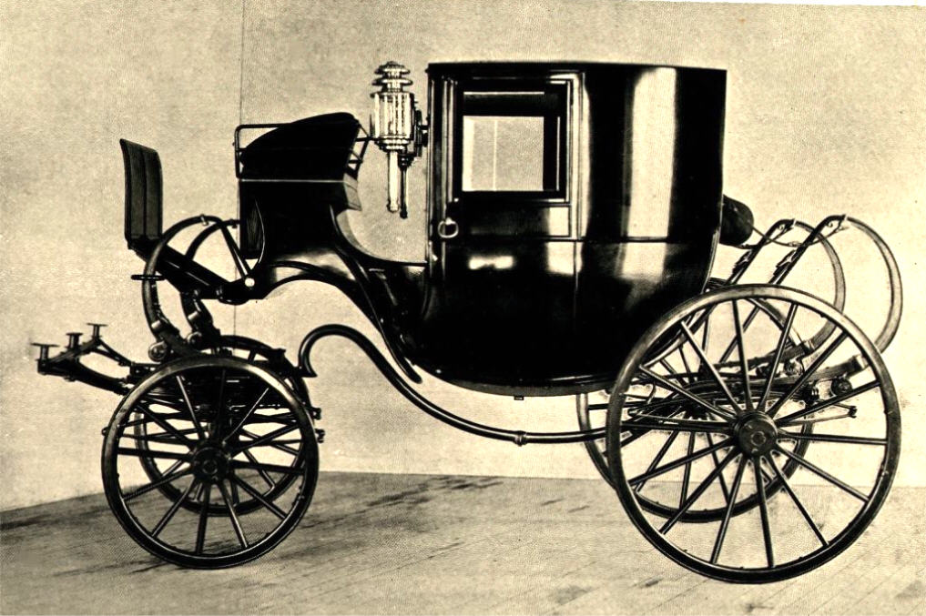

The Carriage House
is the perfect venue for the
Romantic wedding you have always dreamed of!

The Carriage House can accommodate wedding receptions up to 125 persons in our inside Main Dining Room and 125 persons in our
Beautiful weather-proof Garden Terrace.

We offer a “sit down” or “buffet style” all inclusive wedding package
starting at $54.95 per person which includes your choice of
Three entrees, house salad, fresh vegetable, potato, & fresh bread.
The package also includes your personalized wedding cake,
Champagne toast, coffee & tea, & your choice of linen napkin color.

No need for a wedding planner, with the help of our friendly staff,
planning that perfect day will be fun and effortless!
Ask about our in-house florist, photographer,
and excellent entertainment contacts!
Thinking of having the Ceremony here?

Give us a call or stop by to see the beautifully landscaped grounds.
We will assist you in planning your Perfect Day!
~~~~~~~~~~~~~~
Located on Route 29 between Routes 663 and Routes 100
Conveniently located minutes from the turnpike
East Greenville, Pa 18041 ~ 215-679-7700

East Greenville, Pa. 18041
215-679-7700

Circa 1745

Schultheis’ Carriage House Wedding Policies

Food and Beverage:

Children’s menu is available for children under 10
Children under 3 are complimentary
Guests are not permitted to bring in their own food/alcoholic beverages
Wedding cakes brought in are subject to cake cutting service fee
No left over food will be permitted to pack up to go due to insurance liabilities

Facility

• We can accommodate wedding ceremonies for up to 140 guests outside,
& 116 guests inside.
Saturday night booking a minimum of 85 guests in main dining room
No minimum guest count for the outside garden terrace
Smoking is permitted in designated areas only; cigar smoking is not permitted at all
We are not responsible for lost or stolen articles
We are not responsible for the damage of any outside equipment brought in
We reserve the right to volume control if you have a band or DJ
Licensed Entertainment must contact coordinator one week before the Party date to
to insure success of overall planning of the event.
Ceremony site fee 350.00 dollars

Payment

We Require a 500.00 deposit to hold date
Final Payment and guest count must be submitted two weeks in advance
Final guest count may not decrease; but, may increase
The Carriage House closes at 10:00 pm arrangements to stay longer must be authorized in advance
If you schedule both your rehearsal dinner and your wedding reception at
The Carriage House, you will receive a 10% discount from your Dinner Bill.
If you schedule your ceremony and reception 11am-4pm or your reception for 12pm-4pm, you will receive a 10% discount off of your Food total.
All prices and items are subject to change
We accept Visa and Master card limited to 500.00 dollars
We accept check or cash final payment due two weeks prior to the event

