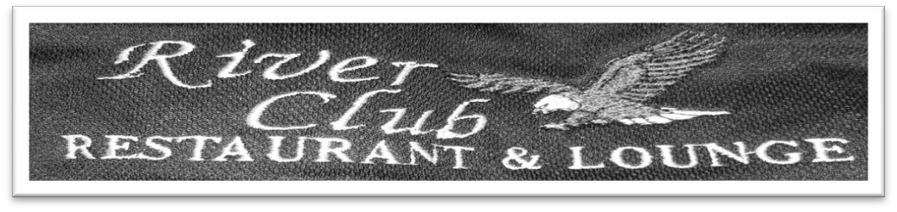

The Afton River Club

Banquet Menu

Contents:

Hors D’oeuvres Page 2

Entrées Page 3

Open Bar Options Page 5

Policy Statement Page 6

Hors D’oeuvres and Appetizers
Cocktail Hour
Veggie Platters $2.00 per person
Pepperoni and Cheese Platters $3.00 per person
Italian of Swedish Meatballs $2.50 per person
Stuffed Mushrooms $2.50 per person
Boneless Chicken Wing Bites $4.00 per person
Bacon Wrapped Scallops $6.00 per person
Jumbo Shrimp Cocktail $8.00 per person

Montage Table $6.00 per person
Montage Table includes an assortment of fresh fruit, pepperoni, cheese, crackers, veggies and dips.

Entrées
Dinner Hour Served Buffet Style
$23.95 per person

Salads

(Select two options) House Garden Salad Caesar Salad Macaroni Salad Potato Salad Marinated Pasta Salad Three Bean Salad
Ask about our seasonal salad options!

Entrées

(Choice of two meat options plus one pasta option) Marinated Chicken Breast
Chicken Marsala Baked Ham Roast Pork Loin
Baked Haddock with Lemon Butter Sauce Roast Turkey with Gravy
Baked Ziti Macaroni and Cheese
Pasta Marguerite

Dinner also includes Chef’s choice of appropriate starch, vegetable, rolls, butter, coffee and tea.

ADD CARVING STATION

Honey Glazed Ham $3.95/person

Roast Turkey Breast $3.95/person

Prime Rib of Beef $7.00/person

*If there is any specific menu item you had in mind let us know and we will work with you to the best of our ability!
*Subject to 8% sales tax and 20% gratuity (prices are subject to change)

Open Bar Prices

Call Open Bar
Includes Name brand liquors, House wines, Domestic bottled beer, Soft drinks & juices

First hour $9.00/person Second hour additional $7.00/person Third hour additional $3.00/person Fourth hour additional $1.95/person
$20.95 per person for call Open Bar for Four (4) hours
Upgrade to top shelf bar which includes Cognacs & ultra-premium liquor for an additional $6.00 per person for four (4) hours

House Open Bar
Includes House brand liquors, House wines, Domestic bottled Beer, Soft drinks & Juices

First hour $7.00/person Second hour additional $6.00/person Third hour additional $2.00/person Fourth hour additional $1.00/person
$16.00/person for House Open Bar for Four (4) Hours

Draught beer, Wine and Soft Drink Open Bar
Includes Draught beer, House wines (merlot, cabernet sauvignon, white zinfandel, chardonnay, and pinot grigio, and a variety of soft drinks and juices

First hour $5.00/person Second hour additional $4.00/person Third hour additional $2.00/person Fourth hour additional $1.00/person
$12.00/person for Draught beer, wine and soft drink open bar for four

*Subject to 8% tax and 20% gratuity (prices are subject to change)

Afton River Club Policy Statement
We must be notified of a final guest count and menu 2 weeks prior to the event. This is the number of guests that will be charged for even if a lesser number of guests attend the event, if a greater number of guests attend the bill may be adjusted accordingly.

Guests are prohibited from brining in or removing food or alcohol from the premises with the exception of wedding cakes and cookies. Proof of age is required to be served alcohol with no exceptions.

Four hours if the allotted time for events; this is flexible subject to availability.

A $1,000.00 non-refundable deposit is required at the time of booking for Wedding Receptions to save the date. This deposit will then be deducted from the total bill. Full payment is due a minimum of 7 days prior to the event. Payments may be made in cash of check. Payments made by credit card are subject to a 4% surcharge.

There is also a $300.00 fee to have the wedding ceremony on premises.

Signature: Client
Date:

Signature: _ Date: River Club Rep

