Meeting & Banquet Room Rental:

♦ One room total: 756 square feet total of Meeting Space

Audio Visual Equipment:
♦ LCD Projector $75.00 per day, plus tax
♦ Easel/ Flip Chart $15.00 per day, plus tax
♦ 42 Flat Screen TV & DVD $60.00 per day, plus tax
♦ 8 foot Pull down Screen $20.00 per day, plus tax
♦ Full Service Catering provided through recommended off site catering companies
♦ All special request for Audio Visual provided through an offsite A/V company (72 hour notice required)

Room Name | Square Feet | Classroom | Banquet  (Longs) | U-Shape | Theater | Hollow  Square | Conference
Meeting Room | 756 | 54 | 48 | 24 | 60 | 30 | 16

Rates:

Meeting Room: $ 250.00

The above prices do not reflect 20% service charge or 7.25% sales tax.
Price is subject to change.

Additional catering options available.
Please ask Director of Sales for details and additional menus.

5580 Interstate Blvd. Youngstown, Ohio 44515 • 330.505.9935

Breakfast Options:

Coffee & Tea per pot: Large: 32 cups $28
Regular, Decaf Med: 24 cups $24
Assorted teas. Small: 12 cups $14

Coffee Break: $3.95 per person
Regular and decaffeinated coffee,
variety of donuts.

Continental: $4.95 per person
Regular and decaffeinated coffee, tea,
assorted juices, and a variety of breads,
bagels, and donuts.

Deluxe Continental: $6.95 per person
Regular and decaffeinated coffee, tea,
assorted juices, and a variety of breads,
bagels, and donuts. Also includes fresh
fruit.

Breakfast Buffet: $9.95 per person
(served off of the breakfast buffet in lobby)
Regular and decaffeinated coffee, tea, milk
and assorted juices. Variety of breads, bagels,
and donuts. Variety of seasonal
whole Fruits. Hot and cold cereals, yogurts and toppings.
Choice of artisan sandwiches.

Pricing does not reflect service charge and sales tax.

5580 Interstate Blvd. Youngstown, Ohio 44515 • 330.505.9935

Beverage Options:

Coffee & Tea per pot: Large: 32 cups $28
Regular, Decaf Med: 24 cups $24
Assorted teas. Small: 12 cups $14

Soft drinks:
Variety of soda drinks, based on
consumption.
20oz plastic bottle $2.00 each

Bottled Water: $1.75 per bottle
Bottled water, based on consumption.

Fruit Infused Water Station: $25.00/day
Fresh Fruit Infused Water served in dispenser. Complimentary Refills
Serves 40 cups

Assorted Juices: $5.00 per pitcher
Choice of Apple or Orange.
Served in pitchers.

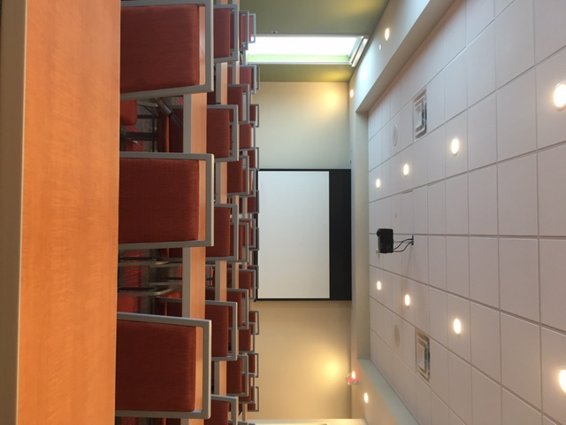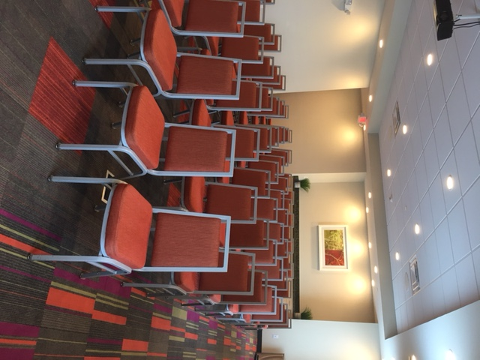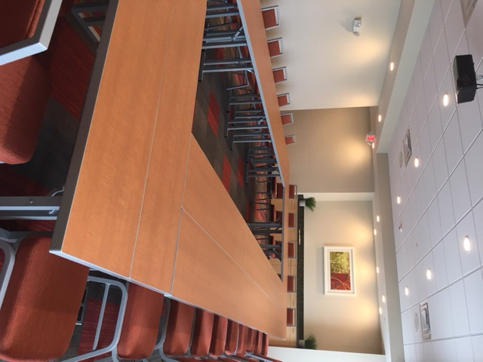

Pricing does not reflect service charge and sales tax.

5580 Interstate Blvd. Youngstown, Ohio 44515 • 330.505.9935

Catered Breaks (Must be ordered at least 72 hours in advance.)

Grand Slam: $4.50 per person
Cracker Jacks, Peanuts, Popcorn, (Minimum 10 People)
M&M’s (Individually packaged)
Assorted Soda.

Candy Craving: $3.95 per person
Variety of two candy bars, Twizzlers,
and M&M’s (chocolate and peanut).
Assorted Sodas.

Healthy Choice: $4.50 per person
Granola Bars, Variety of Light “On the Go” (Minimum 10 People)
singles, Fat Free Pudding cups, Sugar Free
JELLO cups. Fresh whole fruits
Bottled Water.

Sweet and Salty: $4.95 per person
Assorted Chips, Variety of Miniature Hershey (Minimum 20 People)
Bars and Assorted Soda.

Pricing does not reflect service charge and sales tax.

