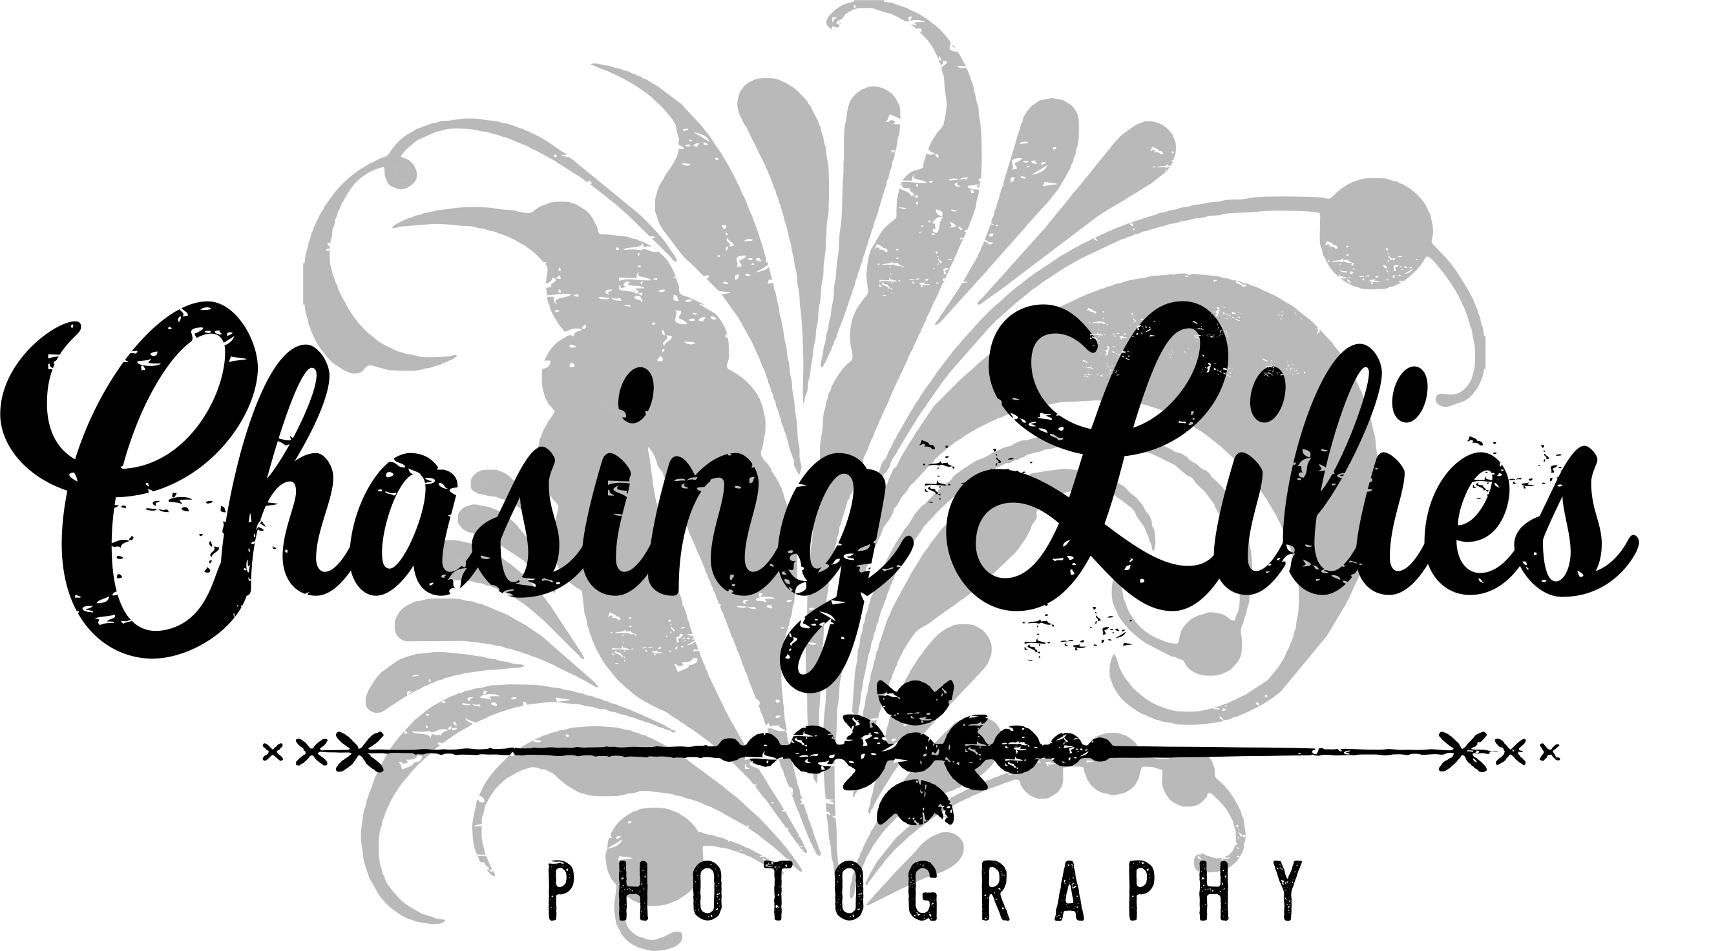

We strive to capture our couples as who they are, how they love one another, and tell the story of that love. We want a couple’s pictures to be a reflection of them that is unique and editorial.

Wedding Collections

Wedding Package #1 $2450

-8 Hours of Consecutive Wedding Day Photography Coverage
-1 Photographer
-Consultation
-Detailed & Custom Timeline
-Unlimited Images & Locations
-High Resolution Images with Print Release
-Private Online Gallery, Sharing & Ordering
-Wedding Images on USB
-80 miles included in package. Additional mileage is $0.55 per mile from Appleton, WI.

Wedding Package #2 $3150

-Engagement Session
-9 Hours of Consecutive Wedding Day Photography Coverage
-1 Photographer
-Consultation
-Detailed & Custom Timeline
-Unlimited Images & Locations
-High Resolution Images with Print Release
-Private Online Gallery, Sharing & Ordering
-Wedding Images on USB
-80 miles included in package. Additional mileage is $0.55 per mile from Appleton, WI.

Wedding Package #3 $3950

-Engagement Session
-10 Hours of Consecutive Wedding Day Photography Coverage
-1 Year Anniversary Session
-1 Photographer
-Consultation
-Detailed & Custom Timeline
-Unlimited Images & Locations
-High Resolution Images with Print Release
-Private Online Gallery, Sharing & Ordering
-Wedding Images on USB
-Free Travel

Wedding Package #4 $5450

-Engagement Session
-10 Hours of Consecutive Wedding Day Photography Coverage
-1 Year Anniversary Session
-2 Photographers
-10x10 Flush Mount Album – 20 pages
-Consultation
-Detailed & Custom Timeline
-Unlimited Images & Locations
-Private Online Gallery, Sharing & Ordering
-Wedding Images on USB
-Free Travel

Elopement Collections

Elopement Package #1 $775

-2 Hours of Consecutive Wedding Day Photography Coverage
-Consultation
-Detailed & Custom Timeline
-Unlimited Images
-High Resolution Images with Print Release
-Private Online Gallery, Sharing & Ordering
-Wedding Images on USB
-$0.60 per mile travel fee from Appleton, WI (round trip)

Elopement Package #2 $1100

-3 Hours of Consecutive Wedding Day Photography Coverage
-Consultation
-Detailed & Custom Timeline
-Unlimited Images
-High Resolution Images with Print Release
-Private Online Gallery, Sharing & Ordering
-Wedding Images on USB
-Free travel up to 1 hour from Appleton, WI ($0.60 per mile travel fee after-round trip)

Looking for hourly coverage…

We understand… that’s why Chasing Lilies Photography LLC also offers hourly wedding coverage. Hourly wedding coverage is $400.00 and must be consecutive (minimum 4 hours). Hourly coverage is only available during off seasons.

A la Carte Services:

Second Photographer $900
(Add onto any wedding package at this flat rate)

Engagement Session $400

-1 hour session
-unlimited images
-touch ups and enhancements
-downloadable high resolution images & rights to print
-password-protected online ordering gallery for 30 days
***

1 Year Anniversary Session $400

-1 hour session
-unlimited images
-touch ups and enhancements
-downloadable high resolution images & rights to print
-password-protected online ordering gallery for 30 days

Boudoir Photography Sessions

***Information/Pricing Available Upon Request***

***Album(s), Guestbook(s), etc. pricing/information available upon request***

Reserve/Payments:

Wedding packages require a deposit of 1/3 the total price to hold your special day. The remaining balance is due no later than 30 days prior to the day of the wedding. Calumet County sales tax will be added to the total.

Chasing Lilies Photography accepts checks & payments via Pay Pal & Venmo. Pay Pal transactions need to include the 2.9% fee on top of the amount owed to process your total payment. Payment via Pay Pal can be sent to caseychasingliliesphotography@gmail.com. Venmo transactions include no fee & can be sent to casey@chasingliliesphotography.com. Checks should be made payable & sent to:

Casey Hein
1120 New York Ave
Manitowoc, WI 54220

Please contact for direct quote. Prices are subject to change without notice. We will honor the current prices at booking and contract.

Prices are subject to change without notice. We will honor the current prices at booking and contract. Engagement sessions/1 Year Anniversary Sessions not in the Outagamie County inquire $0.55 per mile.

