Tiki Sunset Retreat

Where It’s Always Happy Hour

Thank you for considering our venue for your special occasion! We are a unique venue located in the heart of Ft. Lauderdale. Our space will make you and your guests think you have just landed in the Caribbean! We are a family-based business, and our only goal is to help you make your celebration as special and unforgettable as possible. Below please find the packages that we have available. Keep in mind that anything can be modified or changed. If you have any questions about the packages or the venue, please feel free to contact us. Thank you!
Best regards,
Melonie Vanderpool
718 593-2851
Tiki Sunset Management

- A refundable deposit of 25% is required to book the event.
- The full balance is due 10 days prior to the event.
- In the event of a cancellation, all payments will be refunded minus 25% for holding the date. Events cancelled within 5 days of the event will be rescheduled to an available date at no extra costs. Or receive a refund of 50% of total balance.
- All events receive 1 hour prior to the event for setup. Break down and clean up must occur within 30 min after event. (If more decorating time, please let us know). All events must end on time, or the refundable deposit will be compromised. (No later than 10pm)
- Onsite Catering Options available (upon request)
- Bar packages available (upon request)
- We accept credit card or Zelle payments
- Special pricing for conferences, meetings, or events of 20 guests or less
Tiki Sunset
“Cool Vibes Package”
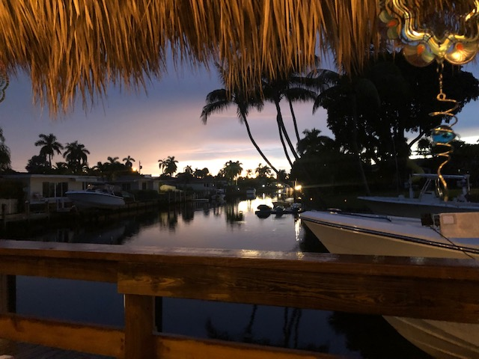
$1,199 (4 hours)
Includes:
- Tiki Sunset Venue
- Existing furniture (seating/tables) for up to 40 ppl
- Speaker w/microphone
- Coolers
- Portable bar
- 1 table for buffet *1 table for dessert
- Food Warmers
- Lighting

Tiki Sunset
“Happy Hours Package”

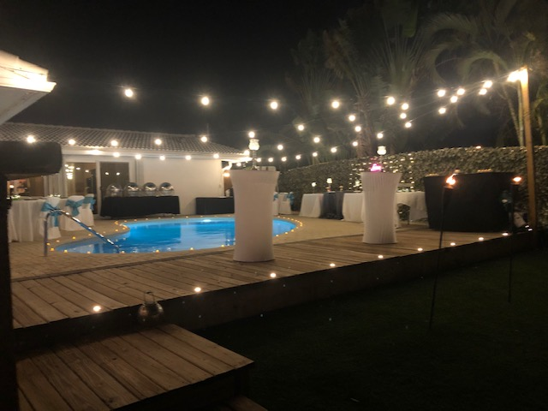
$1,495 (4 hours)
Includes:
- Tiki Sunset Venue
- Portable Bar
- Speaker w/ Microphone
- Tables and Chairs for 40 people Includes: Tables, napkins, chairs, straws, table linens, (white /black)
- Coolers
- 1 table for buffet *1 table for dessert
- Microwave
- Food Warmer’s
- Tiki Torches
- Lighting

Tiki Sunset
“Caribbean Glam Package”
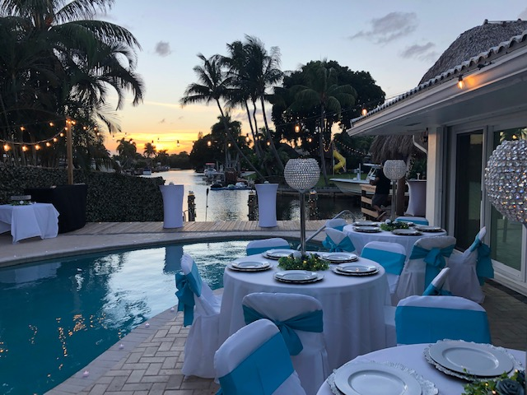
$1,795 (4 hours)
Includes:
- Tiki Sunset Venue
- Bar & Bartender
- Formal round/square Tables and Chairs for 40 people Includes: plates, table linens, (color of choice) flatware, napkins, chair sashes, white chairs, cups
- 1 table for buffet *1 dessert table
- Speaker w/ microphone
- microwave
- Coolers
- Centerpieces/ Decorations
- Food Warmer’s
- Tiki Torches
- Lighting

Additional Add ons
- Catering
- Centerpieces
- DJ
- Bar package
- Bartender
- server
- Photography
- Edited Music video of event
- Live entertainer (Saxophone/Guitarist/Reggae player)
- Hawaiian Dancers
- Fire Dancer
- Ice cream boat
- Floating Lanterns/Wishing paper Lanterns
- flowers
- Decorations (for any occasion)
- Balloons or Flower garland
- pool
- Grand boat entrance
- Please ask about our Special *Hibachi Dinner option

Tiki Sunset Retreat