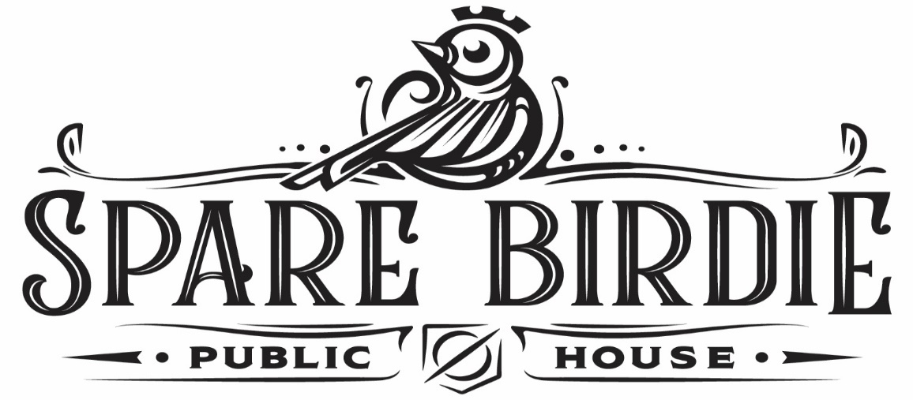

Thank you for your interest in Spare Birdie. For events with 60 or more quests, we offer full building buyouts. I have attached the food and beverage packages for you to review. All buyouts give the group full access to all entertainment options at Spare Birdie. This includes Brunswick String Pin Bowling, Virtual Games, Pool Tables, Dartboards, outdoor Bocce Ball, Cornhole, and Trash Can Beer Pong.

As a buyout, you and your group would be the only guests in the building during the time of the buyout.  All groups are allotted .75 cents on the dollar for food and beverage packages. The only requirement in the food and beverage packages is that you must purchase each food or beverage package in the same increment as the size of the group. You are welcome to purchase more than one type of package to help give your group a wide variety of food/beverage options.

Any buy-out that is booked during non-operating hours (Monday to Thursday with a start time of no earlier than 11 am and an end time of no later than 3:30pm) would be $100 per person. Any buy-out that is booked during operating hours will be priced on a day-by-day basis. This means that the price is based on the day of the week, the time and essentially the sales replacement cost. Example – a Monday night buyout would be much less expensive than a Friday night buyout due to the sales replacement cost.

We do not usually book any group more than 120 days out to ensure that we are within our cost constraints and sales trends. We also cannot see exactly what our sales can and will be approximately 6 months from now.   We would be more than glad to book your group for the date you select even if it is more than 120 days out but would need to include a clause that would allow for a price increase, if warranted, to not exceed 10% of the current quoted price. This is being done to ensure that I cover the replacement cost of sales.

All group packages are subject to a 7% service charge, 8.25% tax, and 20% gratuity fee. All group packages are subject to the cancellation policy. All group packages require a credit card on file and a signed contract with all group function details.

Thank you,

Staci McRae

Corporate Event Director

Email: Staci@sparebirdie.com

Cell:512-569-0181