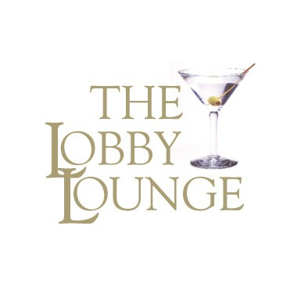

This proposal is designed to help you plan an exceptional experience in The Lobby Lounge. We have included all of the items necessary to arrange your event, and we can customize many details to perfectly suit your wishes and needs. Our gracious Ladies and Gentlemen look forward to serving you while you relax in a warm, refined and relaxed atmosphere.

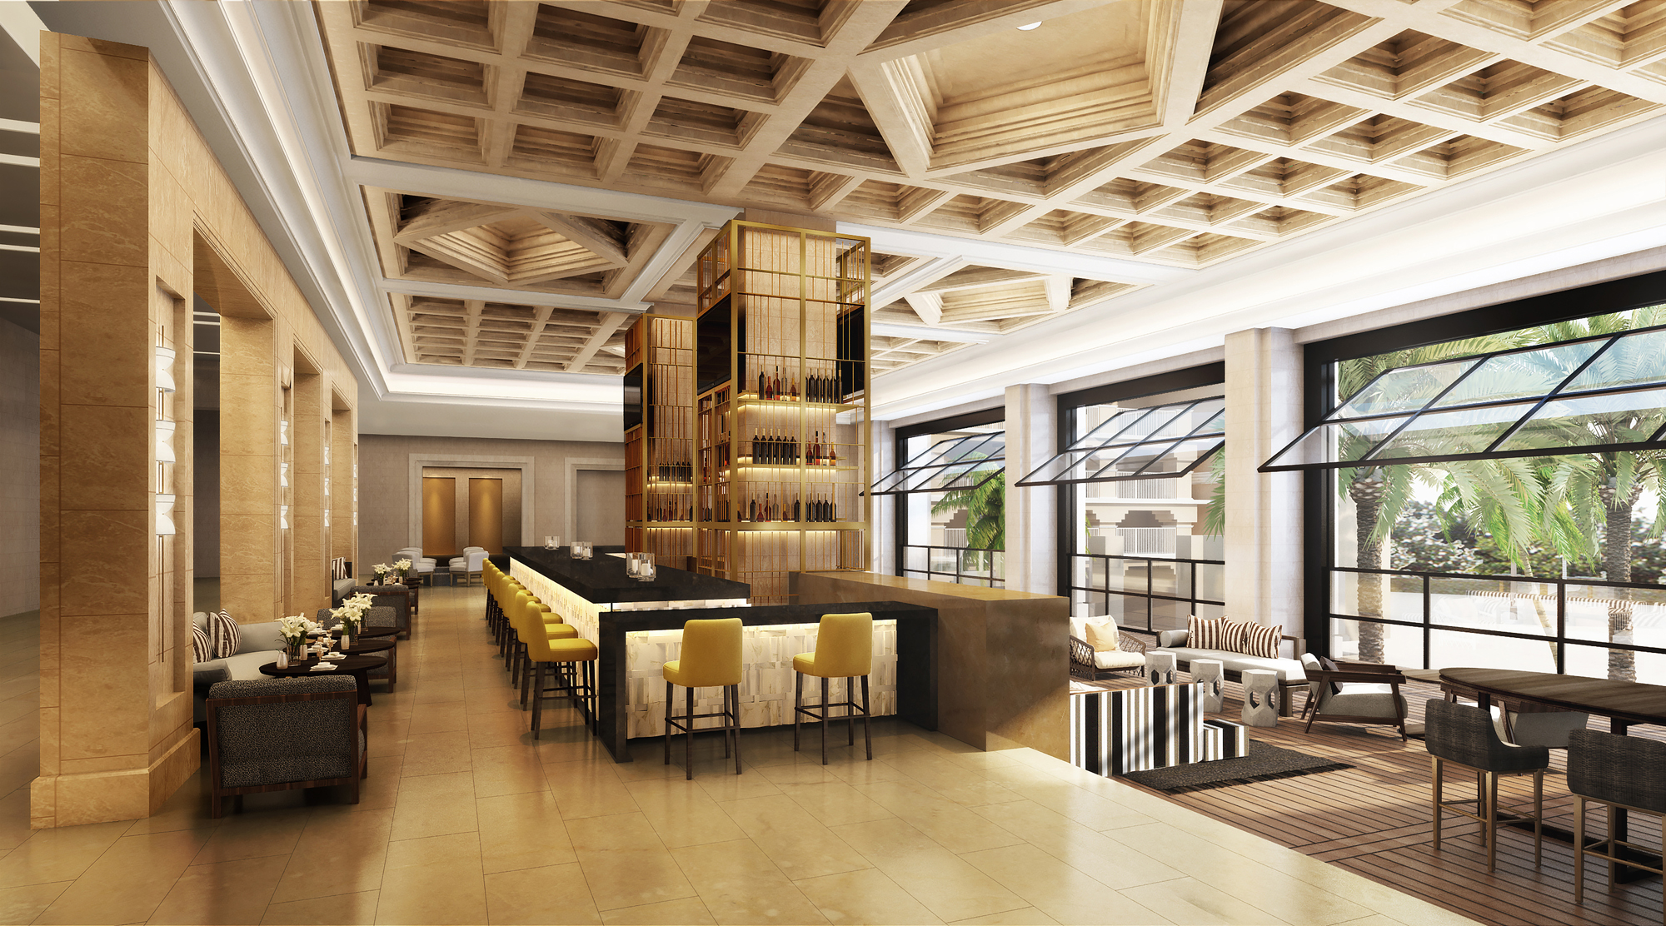

Group Reception Proposal

The Ritz Carlton, Orlando Grande Lakes
4012 Central Florida Parkway, Orlando, FL, 32837
Office: 407-393-4648
Fax: 407-393-4259

Lobby Lounge Reception Menu

Raw Bar Hors d'oeuvres Selection

Cured Salmon Tartare*
Cucumber | Yuzu Koshu | Crème Fraiche | Sturgeon Caviar | Rice Cracker
$14 per piece

Yellowtail Hamachi Sashimi*
(Gluten Free Option upon request)
Shoyu Dashi | Hot Sesame Oil | Bonito Flakes | Ginger Jelly
$12 per piece
Tuna Tacos*
(Gluten Free Option upon request)
Fry Wonton Shell | Kalamansi Ponzu | Togarashi | Avocado
$14 per piece

Wagyu Beef Tataki*
Dark Ponzu Sauce | Black Garlic Aioli| Seasonal Truffle
$16 per piece

Hot Hors d'oeuvres Selection

Fried Shishito
(Gluten Free Option upon request)
White Soy Glazed | Sambal Aioli | Furikake
$9 per piece

Wagyu Beef Spring Roll
(Vegan Option upon request)
Apricot Dipping Sauce
$12 per piece

Shrimp Tempura
Coconut Curry & Sweet Chili Dipping Sauce
$10 per piece

Steamed Pork Gyoza
Shoyu Dashi Dipping Sauce | Scallions
$10 per piece

Pork Belly Bao Bun
(Vegan Option upon request)
Char Siu Glaze | Pickled Cucumber | Carrots | Micro Cilantro
$13 per piece

Crispy Chicken Bao Bun
(Vegan Option upon request)
Chamomile & Citron Brined Tempura Chicken | Kimichi Slaw | Sweet Chili Sauce | Sambal Aioli
$12 per piece

Lobby Lounge Reception Menu

Seafood Bar (20 people minimum)
Served with assorted accoutrement & condiments

Oysters*
$25/person

Shrimps Cocktail
$19/person

Snow Crab Claws
$42/person

Yellowtail Hamachi Sashimi*
$34/person

Bay Scallop Ceviche*
$22/person

Lobster Salad
$21/person

Caviar presentation available upon request* (48 hour notice)
$100/ounce

*Notice: The consumption of raw or undercooked eggs, meat, poultry, seafood or shellfish may increase your risk of foodborne illness

Charcuterie Board (20 people minimum)
Served with assorted accoutrement & condiments

Cured Meat & Cultured Cheese Chef Selection
$42/person

Dessert Station (20 people minimum)

Chef Selection of Seasonally Inspired Desserts
$30/person

Artisanal Cheese Board

BEVERAGE PACKAGES
(All Beverage Packages Are Charged on Consumption)

Beer and Wine
Featuring:

Beers and Wines by the Bottle/Can upon selection

Premium Cocktail Bar
Cocktails range from $18-$20
Featuring:
Absolut Vodka, St. Augustine Gin,
Bacardi Silver Rum, Captain Morgan Rum,
Jack Daniels Whiskey, Maker’s Mark Bourbon, Dewar’s Scotch,
Jose Cuervo Tradicional Plata,
Domestic and Imported Beer and Wines upon selection
Beverage Juices, Sodas, and Mineral Water

Luxury Cocktail Bar
Cocktails range from $22-$25
Featuring:
Grey Goose Vodka, Tito’s Vodka
Bombay Sapphire Gin, Tanqueray Gin,
Mount Gay Rum, Knob Creek Bourbon,
Johnnie Walker Scotch, Crown Royal Whisky,
Remy Martin Cognac, Chambord, Grand Marnier, Casamigos Tequila,
Domestic and Imported Beer and Wines upon selection
Beverage Juices, Sodas, and Mineral Water

Private Bartender
Private bar and bartender exclusively for your event
Suggested for all receptions and/or parties of 20 and more

Bartender fee of $125 for the first hour, $35 each additional hour.
*Bar Package not included

Event Contract

Please fax the completed form to Restaurant Reservations @ Fax 407-393-4259

Event Day/Date:
Name of Party/Group:
Event Title:
Attendee Room Accommodations: | JW Marriott ___ Ritz Carlton ___ Local, Drive In_____
Guaranteed Guest Count:

Dining Room Reserved:
Food & Beverage Minimum:
Set Up Request:
Set Up Fee:
(All Events Require a $250 Set-Up Fee)

Additional Set Up Requests:
(Gift Table, Registration Table, etc.)
Event Planner: (Your Name)
Contact on Site:
Phone: (on site for event)

Event Agenda
Please note, if agreed reception time is not honored by guest, promptness of service is not guaranteed.
Events are contracted for 3 hours.
Please see Event Hours and Extensions for more details.

Agenda | Time | Menu Pricing  (per person)
Reception:

Menu Details:

Dietary Restrictions:

Beverage/Wine Selections
Charges based on consumption.
If wine selections are not picked by event date then
we will pick a red and white wine from our Master Wine List.
Private Bartender:
(Suggested for all receptions & parties of 20 or more)
Beer & Wine Only
Open Bar: (Premium - $16-$18 per beverage)
Open Bar: (Luxury - $20-$22 per beverage)
Open Bar: (Craft - $22-$27 per beverage)
Wine Selection or Preferred Price per Bottle:

Billing

Present Check: | Yes ____ No_____
Payment Preference:  (Bill to Master Account, Room Charge, Credit Card on File, etc.) | *If Master Account, please write account number.  *If Room Charge, please specify guest name.

Authorized Signature: U__________________________________
(Agreement to Event Detail)

Special Event Information

Guarantee:
Confirmation of the guaranteed number of guests is required 3 business days from the time of the function, after which time the client will be charged for the guests in accordance with the contracted menu pricing. If the client does not confirm the number of guests, the expected guest count will become the guarantee. In the event the guest count increases after this deadline, The Lobby Lounge is authorized to alter wine and food selections based on availability with prior written approval from the group.

Event Contracts:
Groups that exceed 12 guests are required to select from the customized menus included in this proposal. There will be no separate checks provided for parties larger than 12; all Event Contracts are inclusive of all expenses incurred by the attendees, including, but not limited to: food, alcohol, set-up fees, taxes, and gratuities.

Semi-Private Dining:
Event Hours and Extensions:
The Lobby Lounge Functions (4:00 pm – 11:00 pm)
* Semi-Private Functions for any meal period will require a Food and Beverage Minimum based on the number of guests and availability. Food and Beverage Minimum shortfalls will be charged as room rental.
*All functions/events are contracted for up to 3 hours. An extension fee of $1,000 per hour will apply beyond the contracted 3 hours.

Non-Private: No Food & Beverage Minimum

Service Charge:
A 26% service charge and 6.5% sales tax will be added to all food, beverage and room rental charges.

Payment:
All attendees of the contracted party are required to pay the contracted price per person (i.e. entertainers, security, and planners). Acceptable forms of payment include cash, major credit cards, room charges, or master account charges. Cashier’s checks, business checks and personal checks cannot be accepted as payment. There will be no separate checks provided for parties of 12 or more. All Event Contracts are inclusive of all expenses incurred by the attendees, including, but not limited to: food, alcohol, set-up fees, taxes, and gratuities.

Menus:
The Lobby Lounge will provide personalized menus for the event. The Lobby Lounge sources the freshest product on a daily basis. The menus provided are an example of the cuisine: however options are subject to change. All meat will be prepared to the chef-recommended temperature, medium rare/medium, unless otherwise specified. Our menus are based on seasonal and local ingredients and may change based on availability.

Decorations/Signage:
Sign displays and decorations (excluding centerpieces, table favors, place cards, rose petals, pre-lit palm or ficus trees and other related event decorations) brought into the hotel by “Group” must be approved prior to arrival. Signage is to be used outside meeting rooms and ballrooms only. No signage of any kind is permitted in the lobby or on the public grounds.

Initial ________

Audio/Visual:
Amplified audio or audio speakers are not permitted within the indoor dining areas of The Lobby Lounge. Any private event consisting of audio at The Lobby Lounge must conclude by 10 p.m.

Weather Policy:
Should the Local Weather Service report a 30% or more chance of precipitation in the area, the scheduled function will be held indoors in the designated backup area. Temperatures below 60 degrees and/or wind gusts in excess of 20 mph shall also be cause to hold function indoors. This decision will be made no less than four hours prior to the scheduled starting time of the function. Should the decision be delayed by the client & result in a double setup of the function, an additional service charge of $12.00 per guest will be added to the final bill.

Miscellaneous Charges:
Corkage Fee - $35 per bottle of wine
Cake Cutting Fee - $7 per person
Set-Up Fee - $250, all events including tables of 10 or more
Private Bartender Fee - $125 for first hour and $35 for each additional hour
Craft Bartender Fee - $175 for first hour and $35 for each additional hour
Outdoor Heaters Rentals - $175 per heater

Indemnification:
To the extent permitted by law, you agree to protect, indemnify, defend and hold harmless the restaurant, The Lobby Lounge, the Owner and their respective employees and agents against all claims, losses or damages to persons or property, governmental charges or fines, and costs (including reasonable attorney's fees), arising out of or connected with your function, except those claims arising out of the sole negligence or willful misconduct of the restaurant. You represent and warrant that your activities conducted at The Lobby Lounge and in connection with the function shall not infringe the patent, copyright or trademark rights or violate rights of privacy or publicity of any third party.

Force Majeure:
Neither party shall be responsible for failure to perform this contract if circumstances beyond their control, including, but not limited to: acts of God, shortage of commodities or supplies to be furnished by The Lobby Lounge, governmental authority, or declared war in the United States make it illegal or impossible for The Lobby Lounge to hold the event.

Initial ________

Cancellation:
The Lobby Lounge shall be entitled to charge a cancellation fee in the event the client cancels this agreement after acceptance thereof by the restaurant. The fee is based on upon the food and beverage minimum in event that private or semi-private space has been reserved or contracted menu price times the number of guaranteed guests in the event of a non-private reservation in effect at the time written notice of the cancellation is received and cannot be applied towards a future event. These amounts are meant as liquidated damages and not as a penalty.

Cancellation of Affiliates: This Party hereby acknowledges that this Event is not being held in conjunction or affiliation with any other program held at the Hotel over the Event Dates. Party’s attendees will not be attending any other program currently being held at the Hotel or in the City of Orlando. If the Hotel determines that another such program exists, Hotel may cancel this Agreement, and the Party shall pay Hotel the Cancellation Fees listed in the Cancellation paragraph of this Agreement.

Cancellation Fees:

Notification of Cancellation Prior to Scheduled Event | % of Total Estimated Food & Beverage Minimum
72 Hours | 100% of the F&B minimum or contracted menu price and other agreed upon fees*
7 Days | 75% of the F&B minimum or contracted menu price and other agreed upon fees*
8-14 Days | 50% of the F&B minimum or contracted menu price and other agreed upon fees*
15-30 Days | 25% of the F&B minimum or contracted menu price and other agreed upon fees*

*Fees may include but are not limited to Bartender Fees, Chef Attendant Fees, and Cabana Rental Fees.
If applicable, state and local taxes will be added to the amounts listed above.

Provided that Party notifies The Lobby Lounge of the Cancellation and timely pays the above liquidated damages, The Lobby Lounge agrees not to seek additional damages from Party relating to the Cancellation.

Authorized Signature:

Date:

