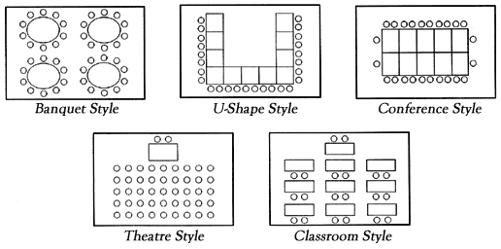
Room Setup Styles
Classroom Style Seating Max: 24 people
Theater Style Seating Max: 30 people
Conference Style Seating Max: 15 people (estimate)
U-Shape Style Seating Max: 20 people

Food & Beverage Options
Fresh Coffee Service | Cost of Service
All-Day Service (in lobby) | Free of Cost
Partial/Half Day Service (in room) | $20.00+tax per day
Full Day Service (in room) | $30.00+tax per day

Catering Options
Apple Spice Box Lunch Delivery &Catering | 701 68th St. SW, Unit 410  Byron Center, MI 49315 | 616-805-3288  Apple Spice Catering Grand Rapids | Box Lunch | Order Today!
Fresh Coast Kitchen | 1633 28th SW, Suite L, Wyoming, MI, 49519 | 616-608-5121  Menu – Fresh Coast Kitchen
Panda Express | 1717 Marketplace Dr SE, Caledonia, MI 49316 | (616) 278-0309  Catering - Kalamazoo Ave & Marketplace Dr, MI | Panda Express

