**Corporate Meeting Planner Package**

We look forward to the possibility of working with you on your next meeting, conference, corporate retreat, incentive trip or social gathering. The following pages offer information that may be helpful to you in considering our property for your next event. Our Professional Meeting Planners are located   
on-site and available to answer any of your questions.

The Resort sits on top of a hill at the base of White Horse Ledge with beautiful views of Mount Cranmore and walking trails to nearby Echo Lake State Park. The location leads guests to feel tucked away in the mountains, and yet the center of North Conway Village, a quintessential historic New England village is just 5 minutes away with over 150 tax-free shops, outlet stores, museums, taverns, cafes and a historic train station to explore.

The White Mountain Hotel & Resort is the perfect location for your next event.

The White Mountain Hotel & Resort guest rooms are beautifully updated. The contemporary design focuses on bringing the natural colors of the great outdoors surrounding the resort into the room while making the focal point of the room our incredible mountain or cliff views out the windows, centering on a comfortable bedroom feel for our guests.

Run of House Room Suites Feature 2 King Beds

Your group will enjoy our comfortable meeting facilities with complimentary Wi-Fi internet access and award-winning cuisine in Ledges Restaurant and the Tullamore Tavern. After a day of meetings your participants can relax in the deluxe guest rooms that feature pillow-top mattresses, high thread-count sheets, down-like blankets and pillows, refrigerators in every room and much more. Our year round, outdoor heated pool and hot tub are very popular, as is our fire pit, fitness center and game room. The outdoor pickle ball courts, shuffleboard, corn hole and basketball courts are great for team building activities. And seasonal hikes from our property are enjoyable in all four seasons. Massage services are available on site in our Spa Services room.

North Conway is truly a four-season resort town. Hale’s Location Golf course, located on property, has been called “One of the most unique and spectacularly beautiful golf developments in the country”, by *Golf Magazine*.

During the winter, guests may purchase ski lift tickets to area resorts, book a sleigh ride, go on an ice climbing adventure, cross country ski, snowshoe or snowmobile to name a few.

We have procured many outdoor enthusiast guides for a variety of guided activities for groups. Our professional event staff is available to assist in booking outings for group activities.

If you dream it, and it’s possible to do, we will do whatever we can to help you book it.

This Meeting Planner Package contains introductory information about our hotel with detailed menus and planning ideas to explore.

We are an independent family-owned hotel. This enables a level of personal touch not always possible at all hotels. The perfect blend of upscale offerings and cuisine with friendly and professional service.

To learn more, please call me or contact the Group Sales Department at **1-800-533-6301, or meetings@whitemountainhotel.com.**

Thank you for considering the White Mountain Hotel & Resort.

Sincerely,

Karen Griffin

Group Sales Manager  
**White Mountain Hotel & Resort**

PO Box 1828

North Conway, NH 03860

Direct: 603-356-5618  
Email: kgriffin@whitemountainhotel.com

**The White Mountain Hotel & Resort**

**Planning Guide Table of Contents**

Introductory Letter…………………………………………………………. pages 1-3

Table of Contents……………………………………………………………. page 4

Corporate Meeting Information Sheet………………………………. page 5

Dining Information ……………………………………………………………...page 6

Meeting/Entertaining Venue Options…………………………….…. pages 7 & 8

Hotel Floor Plan……………………………………………………………… page 9

Spring & Summer Activities……………………………………………… page 10

Fall & Winter Activities……………………………………………………. page 11

WMH Balanced Spa Menu...………………………………………….…. page 12 & 13

2024/2025 Menus……………………………………………………………………pages 14-25

Continental Breakfast & Standard Meeting Breaks….. page 14

Specialty Breaks…………………………………………………… page 15

Buffet Breakfast…………………………………………………… page 16

Corporate Lunch…………………………………………………...page 17

Group Dinner Specialties………………………………………. page 18

Stations Dinner Chef Attended & Served………………… page 19

New England Lobster Bake Menu

Chef Attended & Served………………………………………… page 20

Summer BBQ Menu……………………………………………… page 21

Hors D’oeuvres Selections – Set…………….………………. page 22

Hors D’oeuvres Selections – Passed……….………………. page 23

Casual Hors D’oeuvres…………………………….……………. page 24

Sample Beverage Service Menu……………………………… page 25

The White Mountain Hotel & Resort Property Location Information…Back Cover page 26

**Corporate Meeting Planner Information Sheet**

**Details of our Complete Meeting Package**

* Deluxe Accommodations
* Complimentary suite upgrade for the group leader with 10 or more rooms. Two complimentary suite upgrades with 30 rooms or more.
* Waived Fee for Echo Ballroom with 10 or more overnight rooms booked. Waived Resort Fees   
  for Corporate Guests, a $25/Night/Room Concession
* An enjoyable breakfast with panoramic mountain views in Ledges Restaurant each morning
* Optional group choice of continental breakfast buffet in meeting room with 50 or more.
* Lunch off the corporate menu in Ledges Restaurant or Tullamore Tavern, or a deli sandwich platter lunch in meeting room
* Dinner selected off-the-menu in Ledges Restaurant, by reservation, or Choice-3 Group Dinner in Echo Ballroom or Ledges Restaurant for larger groups.
* Morning and afternoon refreshment breaks are available
* Guest room and meal taxes and gratuities are included in package prices
* Access to meeting room on a 24-hour basis may be arranged
* Group ticket coordination to area ski resorts in season
* On-site personal Event Services Coordinator
* Use of all hotel amenities including fitness center, year-round outdoor heated pool

and hot tub, game room and fire pit

* Discounts and premium tee times at the on-site Hale’s Location Golf Course with rental clubs available
* 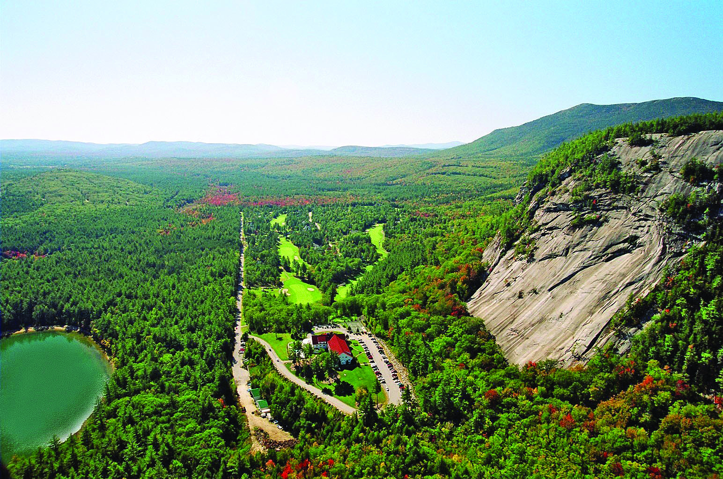(Golf Course is open May-October)

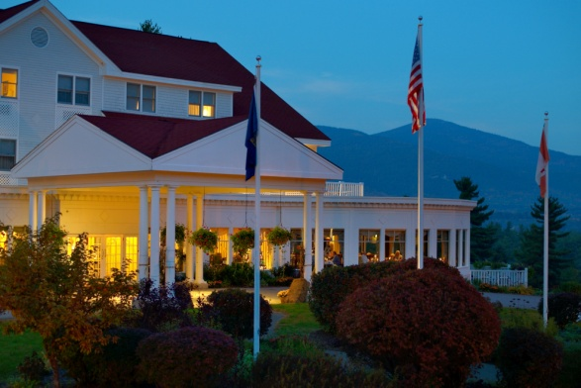**Dining at the White Mountain Hotel & Resort**

Thank you for your interest in the White Mountain Hotel and Resort. The following information and guidelines will help you   
plan your next function or meeting. We are happy to assist you in making the proper menu selections, as well as any special arrangements needed to ensure a successful event. All menu selections, meeting room requirements, and special

arrangements should be submitted to the sales department at least 21 days prior to the function.

**General Dining Information**

Ledges Restaurant offers a full menu of traditional New England favorites and the freshest Maine seafood, along with excellent service, an attentive staff and spectacular panoramic views. Group seating dinner reservations may be accommodated in Ledges Restaurant, or your group may make individual reservations to dine. Group Dinners may also be served in the Echo Ballroom between 5:30pm and 8:30pm. The Tullamore Tavern offers a relaxed atmosphere, with dining off the menu, with seating first come, first served.

Groups of 16 or less will dine off the menu in Ledges Restaurant @ 6pm or 8pm. Dinner includes soup or salad, entrée, and dessert off the menu. Coffee, tea or soda

Groups of 16-25 people will dine in Ledges Restaurant @ 6pm or 8pm and have a choice of 3 entrees from our “Dinner Specialties” Menu.

Groups larger than 25 people will Dine in the Echo Ballroom with a Choice of 3 Entrees from the “Dinner Specialties” Menu.

All dinners include soup or salad, entrée, and dessert off the menu.

Coffee, tea or soda

**Meeting/Entertaining Options**

|  |  |  |  |  |  |
| --- | --- | --- | --- | --- | --- |
|  | THEATER | CLASSROOM | CRESCENT | BANQUET | SQ. FEET |
| Echo Ballroom | 125 | 75 | 50 | 100 | 1,550 |
| Ledges Restaurant | n/a | n/a | n/a | 110 | 1,700 |

*Meetings in Echo Ballroom Banquets or BBQs on the North Lawn Lobster Bakes by the Pool*

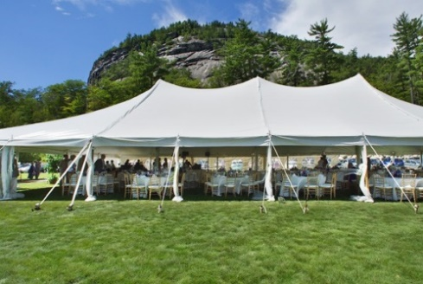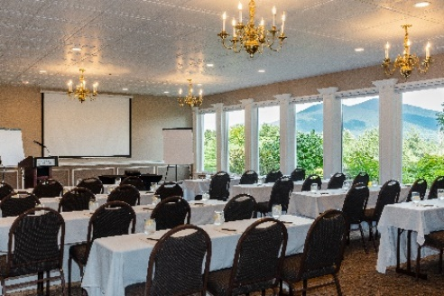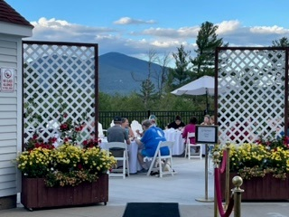

*Live Social and Corporate Events on the North Lawn Fire Pit Parties*

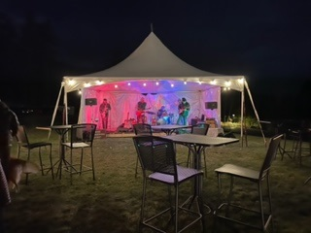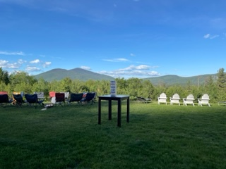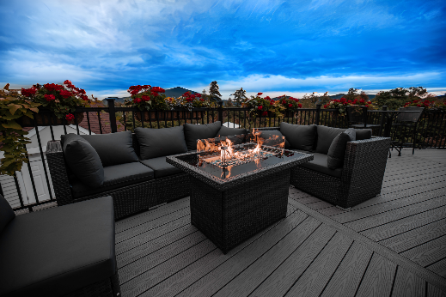

The Tullamore Tavern is a perfect spot for a semi-private cocktail party or casual hang out spot.

The White Mountain Hotel & Resort has a variety of suites with wet bars and comfortable living room spaces for casual meetings and/or entertainment.

**Audiovisual Equipment**

The following in-house audiovisual equipment is complimentary to groups: wall mounted presentation screen in the Echo Ballroom, portable presentation screen, DVD player and TV, flip charts and markers, extension cords, podium with microphone and a Bose Sound system. Complimentary wireless internet service is available throughout the hotel. The hotel will provide a LCD Projector you may rent one for $150 for the duration of your event. We also have a preferred local vendor for clients who require advanced audiovisual needs for their event.

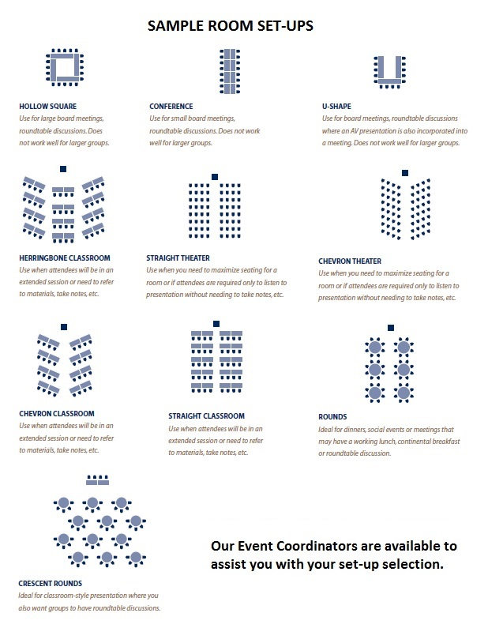

**Spring & Summer Area Activities**

**White Mountain Hotel & Resort Onsite Spring & Summer Activities**

* Hale’s Location Golf Course, a challenging and scenic 9-hole golf course is onsite and open May through October, weather permitting, with discounted rates for hotel guests.
* Outdoor pool, hot tub and sundeck to relax socially or with a good book
* Outdoor basketball, pickleball and shuffleboard court for active fun
* Beautiful Echo Lake State Park, a short walk from the White Mountain Hotel & Resort property is the perfect place to take a relaxing walk-in nature, go swimming, or simply enjoy the reflections of the trees, cliffs and mountains in the lake.
* Hundreds of acres of hiking/mountain biking trails throughout the beautiful White Mountain National Forest nearby, some accessible from the hotel and the golf course.
* Professional guided rock-climbing adventures available to book that start right out the front door of the White Mountain Hotel & Resort on Whitehorse Ledge, adjacent to hotel and Cathedral Ledge, two popular rock-climbing cliffs in New England
* Assistance for booking professional guides for waterfall repelling, mountaineering, kayaking, river rafting, ATVing, horseback riding, bass fishing, fly fishing, and more
* **Nearby Spring & Summer Activities**
* Scenic chair lift rides, mountain coaster or downhill mountain bike lessons at Cranmore
* Factory outlet shopping at over 150 tax-free shops in North Conway
* Conway Scenic Railroad (April through mid-December)
* Mount Washington Cog Railway & Mount Washington Auto Road
* Horseback riding, canoeing, kayaking, and tubing on the Saco River, ATVing
* Cannon Mountain Aerial Tramway
* Wildcat Mountain gondola ride
* Cruise on Lake Winnipesaukee aboard the M/S Mt. Washington
* Storyland (amusement park great for families with young children
* And much, much more…our Sales Team is happy to research other activities upon request

**Fall & Winter Area Activities**

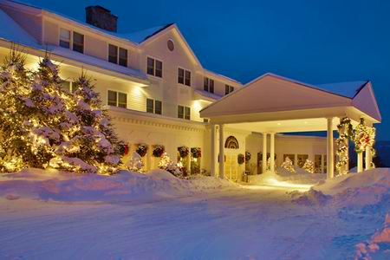

* Cross Country Skiing onsite at the WMH or at Jackson Ski Touring Foundation Ski Resort
* Beautiful Echo Lake State Park adjacent to our property is wonderful for an afternoon of winter hiking or snowshoeing (rental info available)
* Outdoor basketball, pickleball and shuffleboard court during the nice fall days
* Factory outlet shopping at over 150 tax-free shops in North Conway
* Conway Scenic Railroad (April through mid-December)
* Mount Washington Cog Railway (May through November)
* Mount Washington Auto Road (Snow coach tours December through March)
* Horseback sleigh rides, ice skating, dog sledding, back country skiing, snowmobile tours
* Skiing at major ski resorts within a few minutes’ drive from The White Mountain Hotel with group rates available:

Cranmore – 10-minute ride from WMH

Snow tubing (group rates available)

Night skiing

36% beginner, 44% intermediate, 20% expert

Attitash – 20-minute ride from WMH

20% beginner, 47% intermediate, 30% expert

Wildcat – 30-minute ride from WMH

Popular Winding Trails through the Mountain Woods

25% beginner, 45% intermediate, 30% expert

Black Mountain – 20-minute ride from WMH

33% beginner, 33% intermediate, 34% expert

Bretton Woods -40-minute ride from WMH

Many Wide-Open Trails with great views of Mt Washington

23% beginner, 30% intermediate, 47% expert

*And much, much more...we are happy to research other activities upon request*

**"Self-Care is fundamentally about bringing balance back to a life that has grown unbalanced from too many commitments or responsibilities."**  
  
**BALANCE Spa**

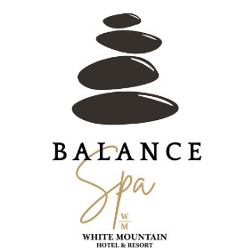

MASSAGE TREATMENTS  
  
**Signature Massage 60/90 Mins**A customized massage including Swedish and therapeutic properties to soothe and ease the body. Addressing targeted areas and allowing relaxation of the body. $130/$190  
  
**Signature Couples Massage 60/90 Min**  
A customized massage including Swedish and therapeutic properties to soothe and ease the body. Addressing targeted areas and allowing relaxation of the body. $260/$380

**Deep Tissue Massage 60/90 Mins**  
A therapeutic massage using firm pressure and slower techniques to reach deeper layers of muscles and fascia. $140/$200

**Hot Stone Massage 60/90 Mins**  
A relaxing massage that incorporates the use of basalt stones warmed to the perfect temperature to aid in muscle pain and aiding in emotional wellbeing and balance. $140/$200  
  
**Prenatal Massage 60 Mins**  
The perfect massage for expecting mothers to relieve stress and alleviate pain. We address the areas of focus while promoting wellness, the perfect massage for relieving tension during pregnancy. $130

**Aromatherapy Massage 60/90 Mins**  
A Swedish massage using one of the following essential oils to promote health and wellbeing during your treatment using Essential oils. $140/$200

**CBD Massage 60/90 Mins**  
A Swedish massage with CBD body oil. Our 1 oz bottles are perfect for massage and the remainder goes home with you. Enjoy CBD oil even at home. $150/$210

**Bamboo Massage 60/90 Mins**  
Warm bamboo sticks is a therapeutic technique using warm sticks to improve circulation and deep relaxation $130/$190

**"It’s not an expense, it’s an investment**.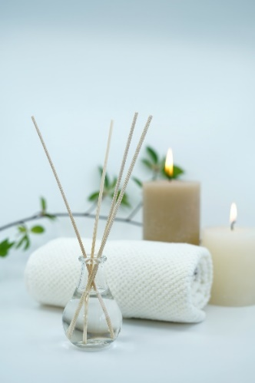

**BALANCE Spa** TREATMENTS  
**Tranquil Touch Treatment 2 Hours**  
CBD Bliss. Enjoy a body scrub followed by a hot stone massage with CBD oil massage along with reflexology of the hands and feet. Finishing with a Face Treatment. Each treatment receives the remainder of the 1 oz bottle of CBD body oil after their treatment. Leaving your skin nourished and your body harmonized. $275

**Essential Escape 2 Hours**  
Our signature massage following a dry brushing of the skin, detoxifying mud wrap and face treatment finishing, with a relieving foot scrub. It’s about the essentials. $265  
 **Himalayan Salt Treatment 60/90 Mins**  
Himalayan salt is extremely beneficial due to the 84 minerals in this sale that are already present in our bodies. This full body treatment provides deep relaxation to the body, mind, and spirit. This is a very light sedating treatment. $140/$200

**Zen & Balance Treatment 90 Minutes**   
Aromatherapy Massage along with our Face Treatment. This leaves your skin dewy and nourished. Breathe easy with essential oils along with facial pampering. $200

**Attune & Ease Essential 90 Minutes**   
Aroma Touch Massage along with an exfoliating foot scrub and reflexology treatment. Essential oil bliss for the body. $200

**Aroma Touch Massage 60 Minutes**  
The Aroma Touch Technique® is the application of essential oil to the back and feet. This technique combines the unique benefits of human touch with the power of essential oils to create an overall wellness experience. $150

FACE PAMPERING  
**Balance Face Treatment 30 Min**/ $70 We will customize your treatment to include skin cleansing, hydrating, a serum, and a relaxing face massage. Relax and unwind with a fully customized face treatment.

SPECIALTY SERVICES  
**Detoxifying Mud Wrap 60 Min**/ $130   
**Hydrating Luxe Body Wrap 60 Min**/$130   
**Exfoliating body scrub and hydrating treatment 60 Min**/$130

ADDITIONAL 30 MINUTE ADD ON SERVICES   
30-Minute Face Treatment $70, 30-Minute Head, Neck & Shoulders $60, 30-Minute Scalp Massage $60, 30-Minute Body Scrub $70, 30-Minute Basic Reflexology $60, & 30-Minute Foot Scrub $60.

OUR THERAPISTS   
All services are performed by NH Licensed Massage Therapists. All Services can be performed as a couple’s treatment.

**Continental Breakfast & Standard Meeting Breaks**

**Continental Breakfast Menu**

Seasonal Cut Fresh Fruit and Berries, Fresh Yogurt and Wholesome Granola

Assorted Cold Cereal, Freshly Baked Muffins & Danish

Assortment of Chilled Fruit Juice

Freshly Brewed Coffee, Decaf & Tea, and Spa Water

**$24.00 per person inclusive of tax, gratuity, and service fee**

**Beverage Break Menu**

Fresh Brewed Coffee, Decaf, Tea, Assorted Soda, and Spa Water

**$20.00 per person, inclusive of tax, gratuity, and service fee**

**Coffee Refresh**

Replenishment of Fresh Brewed Coffee, Decaf, Tea, Spa Water

**$15.00 per person, inclusive of tax, gratuity, and service fee**

**Full Morning Refreshment Break**

Fresh Baked Muffins and Pastry OR Seasonal Cut Fruit and Assorted Yogurt

Served with Fresh Brewed Coffee, Decaf, Tea, and Spa Water

**$20.00 per person, tax, gratuity, and service fee**

**Full Afternoon Refreshment Break**

Fresh Baked Cookies and Brownies OR Assorted Granola Bars and Seasonal Fruit Basket

Served with Fresh Brewed Coffee, Decaf, Tea, Assorted Soda, and Spa Water

**$20.00 per person, inclusive of tax, gratuity, and service fee**

**Specialty Meeting Breaks**

**$25.00 per person inclusive of tax, gratuity, and service fee**

**Morning Break with Fresh Fruit**

Freshly Baked Breakfast Breads and Pastries, Sliced Seasonal Fruit, Fresh Fruit Juices,

Freshly Brewed Coffee, Decaf Coffee, Breakfast & Herbal Teas

**Healthy Break**

Fresh Fruit Kabobs, Yogurt Covered Raisins, Granola Bars

Assorted Yogurts and Crudité Tray

Coffee, Tea, Spa Water, Vitamin Water

**Apple Orchard**

Basket of Whole Seasonal Fruit, Cheddar Cheese and Fresh Baked Apple Turnovers

Hot or cold Apple Cider, Fresh Lemonade, Coffee, Tea, Spa Water

**Go Red Sox**

Large Soft Pretzels, Served with Yellow & Spicy Mustard

Cracker Jacks, Popcorn, Mini Candy Bars, assorted Soda & Spa Water

**Afternoon Elegance Break**

Assorted Imported and Domestic Cheeses

Assorted Crackers & Fresh Fruit Kabobs

Coffee, Tea, Bottled Water

**Chocolate Mountain High**

Assorted Candy Bars, M & M’s, Chocolate Covered Peanuts

Ice Cream Bars & WMH Freshly Baked Cookies

Iced Tea with Lemon, Lemonade, Spa Water

**Snacks to Go**

Assortment of Potato Chips, Pretzels, Candy Bars, Granola Bars

Bananas and Apples, Spa Water & Soda

**Mocktails**

Seasonal Refreshing Mocktails

Additional Themed Breaks Available Upon Request

All final meal counts and choices are due to the Sales Office (21) days prior to arrival.

Prices and menus are subject to change without notice.

*Consuming raw or under cooked meats, poultry, seafood, shellfish or eggs may increase your risk of food-borne illness, especially if you have certain medical conditions. Please allow extra time for medium-well and well-done meats.

**95% of our menu is Gluten Free or can be made Gluten Free.

Buffet Breakfast Menu

**$28.00 per person, inclusive of tax, gratuity, and service fee**

(A minimum of 50 guests required)

**Seasonal Fresh Fruit and Berries** served with Fresh Yogurt and Wholesome Granola

**Bacon & Maple Sausage**

**Country Fresh Scrambled Eggs**

**Our Chef’s own Seasoned Breakfast Potatoes**

**Freshly Baked Muffins & Danish**

**Assortment of Chilled Fruit Juice**

**Freshly Brewed Coffee, Decaf & Tea and Spa Water**

**Additional Add-Ons:**

**Buffet Breakfast with a Chef-Attended Omelet Station   
  
$34.00 per person, inclusive of tax and gratuity and service fee**

Including: Black Oak Ham, Maple Sausage, Bacon, Sliced Fresh Mushrooms,

Sliced tri-color Peppers, Onions, and Tomatoes and Shredded Monterey Jack Cheese

Omelets prepared to order by our skilled Culinary Staff using only the freshest ingredients

All final meal counts and choices are due to the Sales Office (21) days prior to arrival.

Prices and menus are subject to change without notice.

*Consuming raw or under cooked meats, poultry, seafood, shellfish or eggs may increase your risk of food-borne illness, especially if you have certain medical conditions. Please allow extra time for medium-well and well-done meats.

**95% of our menu is Gluten Free or can be made Gluten Free.

**Corporate Lunch Menu**

**$42.00 per person, inclusive of tax, gratuity, and service fee**

Please Make Three (3) Choices Per Meeting Day for Your Group to Select from Each day.

All Entrees are served with the Chef’s choice of dessert and a non-alcoholic beverage.

**Salad Entrees:**

**The “Wedge” Salad** Tender pieces of grilled chicken atop crisp iceberg lettuce with grape tomatoes, Bermuda onion, and bacon lardons topped with homemade, creamy bleu cheese dressing

**Grilled Chicken Caesar Salad** Tender pieces of grilled chicken atop our classic Caesar Salad with homemade “egg-less” dressing

**Sandwich Entrees:**

**White Mountain Burger** An 8 oz burger topped with Vermont White Cheddar Cheese, with sliced tomato, lettuce on a butter toasted brioche roll and pickle served with Cole slaw and chips

**The Tavern** Black Forest ham, all-natural turkey, provolone cheese, smoky maple Dijon mustard, sliced tomato, and lettuce on wheat bread with Cole slaw and chips

**Roast Beef & Gruyere on** a Ciabatta roll with horseradish aioli, Bibb lettuce and vine-ripened tomato, served with Cole slaw and chips

**Grilled Vegetable Wrap** Served warm on an herbed wrap with roasted Portabella mushrooms, grilled zucchini, summer squash, roasted tomatoes, spinach, and Boursin cheese served with Cole slaw and chips

**Soup du Jour & ½ Sandwich:**  Pre-selected **Choice One** of

**Soup du Jour & ½ Roast Beef & Gruyere Sandwich**

Served with chips and a pickle

**Soup du Jour & ½ a Turkey Wrap**

Served with chips and a pickle

**Soup du Jour & ½ Veggie Wrap**

Served with chips and a pickle

**Plated Entrees:**

**Crab Cake** House made crab cake served with a Dijon Remoulade, rice and a fresh vegetable

**Chicken Piccata** A chicken breast lightly breaded and pan seared with lemon, capers and mushrooms with white wine sauce and served with rice and a fresh vegetable

**Marinated Beef Tips** Marinated beef tips with fire grilled peppers and onions served with rice and fresh vegetables

**Boxed Lunch Option***: In Lieu of a Choice 3 Lunch, A Boxed Lunch can be arranged:*

Boxed lunch includes a sandwich, potato chips, a piece of fruit, granola bar, a cookie or brownies and a beverage of soda or bottled water

A choice of three entrées, i.e., beef, chicken/pork and fish must be pre-selected.

All final meal counts and choices are due to the Sales Office (21) days prior to arrival.

Prices and menus are subject to change without notice.

*Consuming raw or under cooked meats, poultry, seafood, shellfish or eggs may increase your risk of food-borne illness, especially if you have certain medical conditions. Please allow extra time for medium-well and well-done meats.

**95% of our menu is Gluten Free or can be made Gluten Free.

**Group Dinner Specialties Menu**

# (for groups of 25 or more people who are dining as a group at the same time)

**$78.00 inclusive of tax, gratuity, and service fee**

# Appetizer Selections (Please select one – additional cost)

# Jumbo Crab Cake baked and served with micro greens, Dijon, and chive rémoulade ($22.00 per person ++)

Three Jumbo Shrimp Cocktail ($16.00 per person ++)

Pan Fried Mushroom Ravioli with local mixed mushrooms, elephant garlic puree ($14.00 per person ++)

# Soup or Salad (Please select one)

Soup, chili, chowder or Garden Salad with House Dressing

**Entrée** (Please select up to three entrées)

|  |  |
| --- | --- |
| **Seared Statler Chicken Breast** (GF)  Seared Statler chicken breast with balsamic vinegar, fig and pistachio glaze, served with rice and farm fresh vegetable    **Broiled Haddock** (GFM)  Fresh haddock prepared with lemon, white wine, butter, and Ritz cracker crumbs served with house rice and farm fresh vegetable  **Herb Crusted Scottish Salmon**\* (GF)  Pan roasted and finished with a caper, Divina olive, tomato caponata, served with Yukon Gold mashed potato and farm fresh vegetable  **Pan Roasted Pork Chop**\* (GF)  Bone in dry rubbed pork chop. Finished with a smoked tomato BBQ sauce and served with Yukon gold mashed potato and farm fresh vegetable | **Surf & Turf**  A grilled Filet Mignon with 2 Shrimp scampi style served with Yukon gold mashed potatoes and farm fresh vegetable  **Grilled Filet Mignon** (GF)  Filet Mignon grilled to your liking, finished with a roasted shallot red wine butter and merlot glacé served with Yukon gold mashed potato and farm fresh vegetable  **Grilled House Cut Steak Tips** (GF)  Prepared in our house marinade with pepper, onions, and mushrooms, served with Yukon gold mashed potato and farm fresh vegetable    **Chef Choice Vegetarian Entrée**    *The following entrée selection is available as an additional choice to groups of 50 or more.*  *Prime Rib is available on Saturday Night for all groups*    **Prime Rib of Beef Au Jus**  Served with Herbed Popovers |

All entrées are served with fresh baked warm bread, Chef’s choice of dessert, and a non-alcoholic beverage.

A choice of three entrées, i.e., beef, chicken/pork and fish must be pre-selected.

All final meal counts and choices are due to the Sales Office (21) days prior to arrival.

Prices and menus are subject to change without notice.

*Consuming raw or under cooked meats, poultry, seafood, shellfish or eggs may increase your risk of food-borne illness, especially if you have certain medical conditions. Please allow extra time for medium-well and well-done meats.

**95% of our menu is Gluten Free or can be made Gluten Free.

Stations Dinner Menu

(A minimum of 50 adults are required for a Stations Dinner)

**$78.00 inclusive of tax, gratuity and service fee**

Includes: A Salad Station, A Chef-Attended Pasta Station, A Chef-Attended Carving Station which includes a selection of Fresh Vegetable and Starch, Freshly Baked Breads, Our Chef’s Special Dessert Station, and Coffee or Tea

**Salad Station:**   
**Build your own Caesar Salad**  
Featuring romaine lettuce, homemade Caesar dressing house croutons, grilled chicken or shrimp and freshly grated parmesan cheese  
**Build you own Garden Salad**  
Featuring fresh assorted greens, homemade dressings, a variety of sliced vegetables and house croutons

## Chef-Attended Pasta Station: Featuring pasta with your choice of marinara, Alfredo or pesto Offered with your choice of shrimp, chicken or scallops and freshly grated Parmesan cheese

**Chef-Attended Carving Station**:   
*(please select one)*  
Prime Rib of Beef  
Roast Sirloin of Beef  
Cider Glazed Pork Loin  
Traditional Roasted Turkey  
Brown Sugar Roasted Ham

**Vegetable Selection on the Carving Station:***(please select one)*Garlic Roasted Broccoli  
Maple Chipotle Roasted Carrots  
Grilled Seasonal Vegetables  
Garlic Roasted Root Vegetables

**Potato or Rice Selection on the Carving Station:**(please select one)Roasted Red Potatoes   
Yukon Gold Mashed Potatoes  
House Rice

**Dessert Station:**A Chef’s Assortment of Delectable Finger Desserts  
Served with Coffee and Tea

Prices are subject to change without notice. Menu items and availability are subject to change.

2017 White Mountain Hotel Meeting Planner Guide

Prices are subject to change without notice. Menu items and availability are subject to change.

2017 White Mountain Hotel Meeting Planner Guide

Prices are subject to change without notice. Menu items and availability are subject to change.

2017 White Mountain Hotel Meeting Planner Guide

Prices are subject to change without notice. Menu items and availability are subject to change.

2017 White Mountain Hotel Meeting Planner Guide

Prices are subject to change without notice. Menu items and availability are subject to change.

2017 White Mountain Hotel Meeting Planner Guide

Prices are subject to change without notice. Menu items and availability are subject to change.

2017 White Mountain Hotel Meeting Planner Guide

Prices are subject to change without notice. Menu items and availability are subject to change.

2017 White Mountain Hotel Meeting Planner Guide

Prices are subject to change without notice. Menu items and availability are subject to change.

2017 White Mountain Hotel Meeting Planner Guide

Prices are subject to change without notice. Menu items and availability are subject to change.

2017 White Mountain Hotel Meeting Planner Guide

Prices are subject to change without notice. Menu items and availability are subject to change.

**New England Lobster Bake Buffet**

**Served Pool Side**

***Chef Attended and Served  
$ Market Price***

**Lobster Bake Buffet Menu Includes**Maine Lobster (1 lobster per person)

**Select One Additional Protein**Grilled Sirloin Steak½ BBQ Chicken

**Select One Steamed Specialty**Mussels  
Steamers

**Select Three Sides**New England Clam ChowderRoasted Red PotatoesHomemade Cole SlawGarden Salad with House Dressing  
Linguica & Chorizo with onion & peppers

Pasta SaladCorn on the CobCorn Bread

**Select One Dessert**Watermelon, Strawberry Shortcake or Blueberry Buckle

**Select Two Beverages**Coffee, Tea and Decaf  
Lemonade  
Iced Tea  
Bottled Water  
Fruit Infused Water

**Bar set up fee is $350.00**

*Price subject to change based on current market price of lobsters, clams and mussels**

Prices are subject to 8.5% NH State Tax and 18% Gratuity and service Fee

Price not guaranteed until contract is issued and signed and is still subject to market pricing

*Consuming raw or under cooked meats, poultry, seafood, shellfish or eggs may increase your risk of food-borne illness, especially if you have certain medical conditions. Please allow extra time for medium-well and well-done meats.

**95% of our menu is Gluten Free or can be made Gluten Free.

Summer Buffet BBQ Menu  
$78.00 inclusive of tax, gratuity and service fee

**Choice of Three:**BBQ Steak TipsBBQ Chicken QuartersHand Pulled BBQ PorkHand Pulled BBQ Chicken

**Choice of One:**Beyond Burgers Handmade Burgers with sliced tomato, sliced onions, and lettuceGrilled Italian Sausage with peppers and onions

**(Choose of One - $10/person upgrade)**Smoked BrisketSmoked Pork ShoulderBraised Baby Back Ribs

**Choice of Four Sides:**Corn on the CobBBQ Baked BeansRoasted Red Potatoes Garden Salad with House DressingCole SlawPasta SaladPotato SaladCornbread

**Includes:**

Watermelon  
Strawberry Shortcake OR Blueberry Buckle  
Iced Tea & Lemonade

Prices are subject to 8.5% NH State Tax and 18% Gratuity and service Fee

Prices are subject to change without notice. Menu items and availability are subject to change.

*Consuming raw or under cooked meats, poultry, seafood, shellfish or eggs may increase your risk of food-borne illness, especially if you have certain medical conditions. Please allow extra time for medium-well and well-done meats.

**95% of our menu is Gluten Free or can be made Gluten Free.

.

HORS D’ OEUVRES SELECTIONS

**Charcuterie Platter**

***A selection of cured meats and international cheeses served with fig butter, Divina olives and house made cracker bread***

small (serves 20-30) $200.00

medium (serves 40-50) $250.00

large (serves 60-75) $300.00

**International and Domestic Cheese, Cracker, and Fruit Platter**

small (serves 20-30) $100.00

medium (serves 40-50) $150.00

large (serves 60-75) $200.00

**Fresh Seasonal Crudités served with Herbed Dip**

small (serves 20-30) $ 50.00

medium (serves 40-50) $100.00

large (serves 60-75) $150.00

**Smoked Salmon Platter** $5.00 per person

French bread crisps, lemon chive crème fraiche, fried capers, hardboiled egg

**Baked Brie with local Strawberry Jam and Brown Sugar** $3.00 per person

**Assorted Finger Sandwiches** $3.00 per person

Chicken, Tuna, and Seafood Salad

Priced for 2 pieces per person

**Strawberries dipped in Chocolate** (in season) $2.50 per person

Prices are subject to 8.5% NH State Tax and 18% Gratuity and service Fee

Prices are subject to change without notice. Menu items and availability are subject to change.

Consuming raw or under cooked meats, poultry, seafood, shellfish or eggs may increase your risk of food-borne illness, especially if you have certain medical conditions. Please allow extra time for medium-well and well-done meats.

**95% of our menu is Gluten Free or can be made Gluten Free.

.

**HORS D’ OEUVRES SELECTIONS**

Spinach & Feta Spanakopita

Bacon, Spinach & Feta Spanakopita

Garlic Sesame Chicken & Pineapple Skewers

Honey Ginger Teriyaki Beef

Sundried Tomato and Feta Crostini

Fresh Caprese Skewer

Miso Salmon Crudo Spoon

**$150 per 50 Pieces**

Sweet Chili Scallops & Bacon

Mini Crab Cakes with Chive Aioli

Prosciutto Wrapped Shrimp Skewers

Short Rib Stuffed Mushroom Wrapped in Phyllo

**$175 per 50 Pieces**

Lobster Arancini

Nori Wrapped Tuna Bites with Soy Syrup

Charred Tenderloin Canapes with Caramelized Shallot & Truffle Crème Fraiche

Smoked Salmon Tar-Tar Spoons

Jumbo Shrimp Cocktail

**$200 per 50 Pieces**

Additional Selections & Themed Menus Available Upon Request

Prices are subject to 8.5% NH State Tax and 18% Gratuity and service Fee

Prices are subject to change without notice. Menu items and availability are subject to change.

Prices and menus are subject to change without notice.

*Consuming raw or under cooked meats, poultry, seafood, shellfish or eggs may increase your risk of food-borne illness, especially if you have certain medical conditions. Please allow extra time for medium-well and well-done meats.

**95% of our menu is Gluten Free or can be made Gluten Free.

CASUAL HORS D’ OEUVRES MENU

For Firepit Parties & Casual Events

**PASSED:**

**Onion Tarts**  $3.00 per person  
Caramelized onion jam baked in puff pastry

**Jalapeno Poppers**  $3.00 per person  
Seasoned chive cream cheese stuffed jalapenos baked in a croissant with a  
raspberry chipotle sauce

**Vegetable Stuffed Cremini Mushrooms** $2.00 per person  
Topped with Great Hill Blue Cheese crumble

**Margherita Pizza Bites**  $2.50 per person

French baguette, fresh mozzarella, tomatoes, and marinara sauce  
topped with fresh basil

**Hot Pigs in a Blanket**  $2.50 per person  
Served with honey mustard dipping sauce

**SET:**

**Maple Pecan Popcorn**  $1.75 per personMaple caramel coated popcorn tosses with toasted pecans

**Soft Pretzel Bites with 4- Cheese IPA Dip** $2.00 per person

Baked Spinach Artichoke Dip $2.00 per person  
Served with pita chips OR corn tortilla chips

**Tahini Sriracha hummus served with pita chips** $2.50 per person

**Homemade “Mac & Cheese”**  $2.50 per person  
Homemade Mac & Cheese served in a chafing dish

Additional Selections & Themed Menus Available Upon Request

Prices are subject to 8.5% NH State Tax and 18% Gratuity and service Fee

Prices are subject to change without notice. Menu items and availability are subject to change.

*Consuming raw or under cooked meats, poultry, seafood, shellfish or eggs may increase your risk of food-borne illness, especially if you have certain medical conditions. Please allow extra time for medium-well and well-done meats.

**95% of our menu is Gluten Free or can be made Gluten Free.

# Sample Beverage Service Menu

**Premium Selections**

Absolut Vodka

Tanqueray Gin

Bacardi Rum

Captain Morgan

Buffalo Trace

Johnnie Walker Red

Dewar’s Scotch

Jack Daniels Bourbon

V.O.

Cuervo Gold Tequila

Hornitos

**Top Shelf Selections**

Cold River

Belvedere Vodka

Bombay Sapphire Gin

Makers Mark

Chivas Scotch

Glenlivet

Don Julio

Patron

Tullamore Dew

Grand Marnier

**Open Bar Prices based Upon Consumption**

**Liquor**

Premium Brands $12.00

Top Shelf Brands $13.00 & up

**Two Liquor Drinks**

Premium Brands $14.00

Top Shelf Brands $15.00 & up

**Cognacs**

Grand Marnier $12.00

Remy Martin $14.00

Courvoisier VS $12.00

**Beer**

Domestic Bottled $ 6.00

Imported Bottled $ 7.00

Imported/Micro Draft $ 8.00

**House Wine** (9oz also available)

House Wine (5 oz. glass) $11.00

Premium Wines (5 oz. glass) $16.00

**Beverages**

Soda $ 2.00

Juice $ 2.00

Sparkling Water $ 2.00

**Punch Bowls** (per 25 people)

Fruit Punch $50.00

Fruit Punch w/ Alcohol $85.00

## Strawberry Champagne Punch $95.00

There will be a $350.00 set-up fee per bar for all bars not held in the Tullamore Tavern

## Prices are subject to 8.5% NH State Tax and 18% Gratuity and service Fee

Prices are subject to change without notice. Menu items and availability are subject to change.

A sample Full Wine List is available upon request.

**Property Location**

The White Mountain Hotel & Resort is located at 87 Fairway Drive, North Conway, NH 03860

Guests flying to our hotel typically fly into Boston Logan Airport (about 2.5 hours away) and enjoy a night in the wonderful city of Boston or fly into Portland International Jetport in Portland, Maine, an easy, small airport to navigate and take the beautiful drive to North Conway (about 1.5 hours). Once outside the outer limits of Portland Maine, it is an enjoyable drive through scenic Maine, with little to no traffic lights until the town of Fryeburg, Maine, right next to the town of Conway, NH.

The hotel is located within the Hales Location neighborhood off West Side Road in North Conway.

The White Mountain Hotel & Resort regularly books motor-coach buses for groups. Please let the Sales Team know if you would like them to quote or book a motorcoach bus for your group.

*“The Only Thing We Overlook are the Mountains”*

**Contact:**

**Karen Griffin, Group Sales Manager**

**603-356-5618**

**kgriffin@whitemountainhotel.com**

**Group Sales 800-533-6301 or meetings@whitemountainhotel.com**

**Let us make your next event a success!**