**Wedding “Build-Your-Own” Packages**

New Beginnings makes every wedding day unique with the options we offer. Our multi-talented staff is available to provide you with a truly one of a kind wedding reception. We believe every new beginning should be unforgettable.

**Base Package- $800** -4hr Reception service, 1on1 planning to write an itinerary, make song selections, and coordinate reception events(See Planner Below). Your DJ/MC will make sure everything is smooth and timely.

**Additional Options- $300 each**- Build your own package and get only what you need to make your dream day a reality.

***Discounts-*** *up to* $**300** *off*

**PromoDisc** *$50-(Shared Event Pics/Vids, Referrals/Reviews)*

***SimpleDisc*** *($50per )-(No Steps/Elevator, Close Load/Park, Close Power)*

**HometownDisc** *(~$100*÷Each 5 Miles From Salisbury, MD*) ($100/$50/$25…)*

**ComboDisc** *($50per added Opt)*

**\*\*\*Options\*\*\***

**(A)** Little Add-Ons(½ Option)

Minor add on services are considered half an option. Such as:

**1** Dance Party Subs/Satellite Speakers **2** Basic Dance Lighting

**3** Added 1 Hour Service

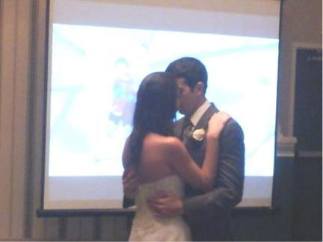

**(B)** Expressions:

*Custom Music Video*

Your pictures and home movies turned into

a heartwarming and elegant presentation

from childhood to engagement. Projected onto

a movie screen at your reception or ceremony.

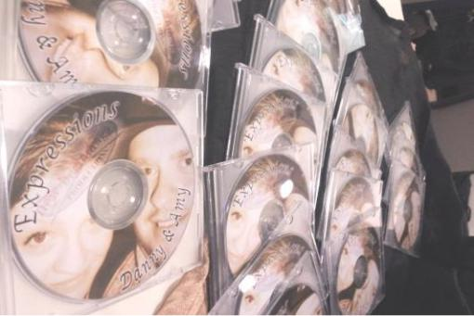

**(C)** Expressions:

*Custom Written Song(x2)*

Tell us your story of how you fell in love and what the love means to you. We will turn it into your own song to be played on your Wedding day.Makes a memorable first dance.

**(D)** Live Performer Guitar, piano, or wind instruments solo player to perform pre-selected music. Even a Dance Teacher- Amber joins your guests to guide them through some group dances, from grandson to grandma, everyone has fun. Country, hip-hop, or pop line dances. Or the wedding party can learn a special dance ahead of time!

**(E)** Ceremony- Extra speakers, time, music, and mics included

1. **Lighting**

Advanced computer operated lighting for dance/atmosphere. Moving Light Show **OR** Uplighting **OR** Monogram(Name in Lights(½ Option)).

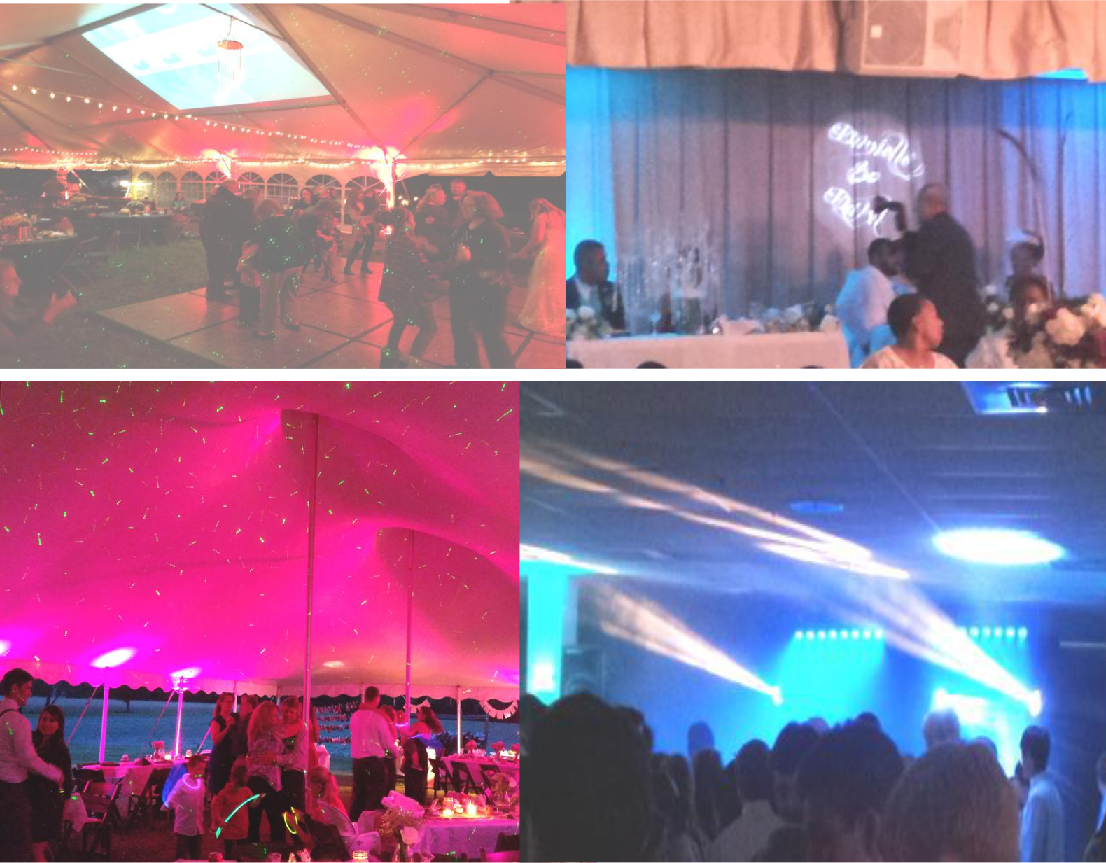

Page 2 of 6

**A Few Words from Past Events!**

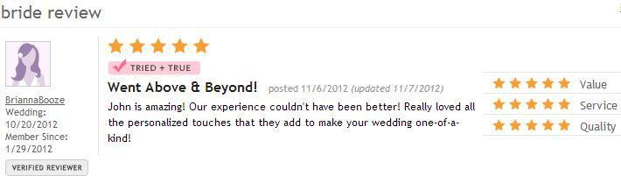

Joshua, Groom "Hey man, Just wanted to reach out and say how great of job you did with the reception man. Thanks so much!! We were so happy with the way everything turned out..."

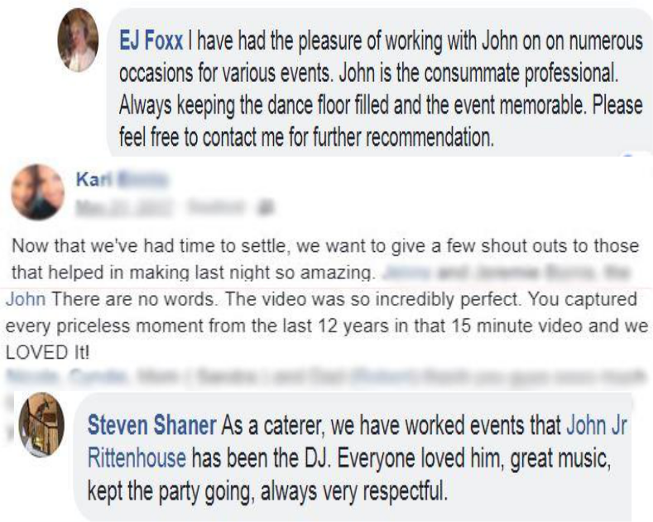

Rachel, Bride- "John was responsive and always pleasant to work with in getting plans together for our wedding reception. He had fantastic feedback and ideas to help with making decisions. Everyone had a great time dancing to the music and were impressed with his lighting and video options. His sense of humor and fun loving nature are a definite help when planning for such a large event. We know we made the right choice - John was definitely the best choice for our wedding entertainment!"

Katie, Bride- "Thank you so much for being the DJ at our wedding. It will probably be a

wedding that you wont forget as it was an outside wedding and we had received a total of 16 inches of rain that week with 4 inches that day. Not one complaint was heard from you and you rolled with it. With the last minute setup due to the rain there were a lot of holes as things were switched around and it seemed at times that we werent going to be able to pull it off. But you pieced everything together and made it perfect without any direction from myself or anyone else. I had so many compliments from people asking who you were and comparing you to other DJ's from weddings saying you were the best one of them all! Thanks again for making our day so special."

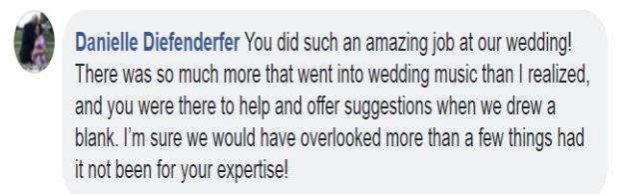

Ken , Groom "John,

Thanks so much for the time you spent with us last night. Denise and I are very excited about having you as our DJ, and your expertise and enthusiasm last night proved that we have made the right choice. Thanks again!! Talk to you soon... Regards, Ken"

Ali , Bride- "Hi John! You were so great to work with!! Very easy going and very accommodating leading up to the day. It was a very hot and rainy day.. but you kept it lively and got everybody dancing in the rain! You provided a great service and I would certainly recommend you to anyone! Thanks John!"

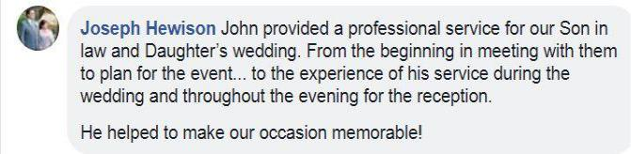

Page 3 of 6

1. **Date:___________ Time(Start of Music to End):____ ____**
2. **# of Guests__________ Indoor or Outdoor?___________**
3. **Location: ________________, ___________________, ____________________**

***(NAME)*** ***(STREET)*** ***(CITY, STATE, ZIP).***

**4. What package are you generally interested in? _________________________**

|  |  |  |  |  |  |  |  |  |  |  |  |  |
| --- | --- | --- | --- | --- | --- | --- | --- | --- | --- | --- | --- | --- |
| **See Wedding Package Details** | | | | | | **Options(A-H) _________________________** | | | | | | |
| **5. Wedding Party Reception Introduction Names & Escorts(With Phonetics):** | | | | | | | | | | | | |
| **Female- First** | | |  | **Last** | | ***“escorted by”* Male- First** | | | |  | **Last** | |
|  |  |  |  |  |  | |  |  |  |  |  |  |
| **_____________** | | | **__________________** | | | | **_____________** | | | **__________________** | | |
| ***(MOTHER OF THE BRIDE)*** | | | | | |  | ***(ESCORT IF NOT FATHER)*** | | | | | |
| **_____________** | | | **__________________** | | | | **_____________** | | | **__________________** | | |
| ***(DATE IF NOT MOTHER)*** | | | | | |  | ***(FATHER OF THE BRIDE)*** | | | | | |
| **_____________** | | | **__________________** | | | | **_____________** | | | **__________________** | | |
| ***(MOTHER OF THE GROOM)*** | | | | | |  | ***(ESCORT IF NOT FATHER)*** | | | | | |
| **_____________** | | | **__________________** | | | | **_____________** | | | **__________________** | | |
| ***(DATE IF NOT MOTHER)*** | | | | | |  | ***(FATHER OF THE GROOM)*** | | | | | |
| **_____________** | | | **__________________** | | | | **_____________** | | | **__________________** | | |
| ***(FLOWERGIRL*)** | | |  |  |  |  | ***(RINGBEARER)*** | | |  |  |  |
| **_____________** | | | **__________________** | | | | **_____________** | | | **__________________** | | |
| ***(JUNIORBRIDE*)** | | |  |  |  |  | ***(JUNIORGROOM)*** | | |  |  |  |
| **_____________** | | | **__________________** | | | | **_____________** | | | **__________________** | | |
| ***(BRIDESMAID* )** | | |  |  |  |  | ***(GROOMSMAN)*** | | |  |  |  |
| **_____________** | | | **__________________** | | | | **_____________** | | | **__________________** | | |
| ***(BRIDESMAID* )** | | |  |  |  |  | ***(GROOMSMAN)*** | | |  |  |  |
| **_____________** | | | **__________________** | | | | **_____________** | | | **__________________** | | |
| ***(BRIDESMAID* )** | | |  |  |  |  | ***(GROOMSMAN)*** | | |  |  |  |
| **_____________** | | | **__________________** | | | | **_____________** | | | **__________________** | | |
| ***(BRIDESMAID* )** | | |  |  |  |  | ***(GROOMSMAN)*** | | |  |  |  |
| **_____________** | | | **__________________** | | | | **_____________** | | | **__________________** | | |
| ***(MAID OF HONOR)*** | | |  |  |  |  | ***( BESTMAN)*** | | |  |  |  |
| **_____________** | | | **__________________** | | | | **_____________** | | | **__________________** | | |
| ***(BRIDE)*** | | |  |  |  |  | ***(GROOM)*** | | |  |  |  |

|  |  |  |  |  |  |  |  |  |  |  |  |
| --- | --- | --- | --- | --- | --- | --- | --- | --- | --- | --- | --- |
| **6. Will you have these events and in what order? What songs or music style?** | | | | | | | | | | | |
|  | **Event Time/Order Song or Music Style** | | | | | | | |  | **Artist** | |
|  |  |  |  |  |  |  |  |  |  |  |  |
|  | **-Ceremony** | | |  |  |  |  |  |  |  |  |
|  | Prelude | | | ___ |  | (Pop Instrumental, Classical, Reggae, Country, ETC) | | | _____________________ | | |
|  | Processional | | | ___ |  | ______________________ | | | _____________________ | | |
|  | Bridal March | | | ___ |  | ______________________ | | | _____________________ | | |
|  | Performance | | | ___ |  | ______________________ | | | _____________________ | | |
|  | Unity Event/  Communion | | | ___ |  | ______________________ | | | _____________________ | | |
|  | Recessional | | | ___ |  | ______________________ | | | _____________________ | | |
|  | **-Reception** | | |  |  |  |  |  |  |  |  |
|  | Intro Music | | | ___ |  | ______________________ | | | _____________________ | | |
|  | First Dance | | | ___ |  | ______________________ | | | _____________________ | | |
|  | Father/Bride | | | ___ |  | ______________________ | | | _____________________ | | |
|  | Mother/Groom___ | | | |  | ______________________ | | | _____________________ | | |
|  | Toasts | | | ___ |  | ______________________ | | | _____________________ | | |
|  | Prayer(Blessing)___ | | | |  | By Whom? ____________ | | | _____________________ | | |
|  | Dinner Music ___ | | | |  | ______________________ | | | _____________________ | | |
|  | Bouquet Toss ___ | | | |  | ______________________ | | | _____________________ | | |
|  | Garter Remove___ | | | |  | ______________________ | | | _____________________ | | |
|  | Garter Toss | | | ___ |  | ______________________ | | | _____________________ | | |
|  | Garter SlideOn___ | | | |  | ______________________ | | | _____________________ | | |
|  | Dollar Dances ___ | | | |  | ______________________ | | | _____________________ | | |
|  | Dollar Dances ___ | | | |  | ______________________ | | | _____________________ | | |
|  | Dollar Dances ___ | | | |  | ______________________ | | | _____________________ | | |
|  | Dollar Dances ___ | | | |  | ______________________ | | | _____________________ | | |
|  | Cake Cut(Sweet)___ | | | | | ______________________ | | | _____________________ | | |
|  | Cake Cut(Messy)___ ______________________ | | | | | | | | _____________________ | | |
|  | Last Song | | | ___ |  | ______________________ | | | _____________________ | | |

Songs You Want to Hear and Special Dedications(list more on back if needed)

1. **Wedding Planner Contact Info:** ___________________________________

***(EMAIL ADDRESS)***

**_______________ _______________________ _______________________**

***(FIRST NAME)*** ***(LAST NAME)*** ***(PHONE NUMBER)***

**Our Wedding To-Do List**

1. **Free Consult**-Meet to discuss your needs and explain ourpackages.
2. **Book your Date**- Decide on a package and set tentative date.
3. **Retainer**- Sign Contract, take care of retainer fee, andsecure your date.
4. **Info Sheets**- Fill out Wedding DJ Info Sheet and othersheets(Song, Video, etc...).
5. **Planning meeting**- Meet to go over general itinerary.
6. **Finalize**- The week before the Wedding, finalize any lastminute changes, pay your remaining balance, and look forward to a well planned and stress-free wedding.
7. **Tell us how we did-** Comment cards are available with your

DJ, or leave comments on Facebook, Google, Yahoo, etc…

Just search for our name.

1. **See yourself**- Look for any promo vids or pics online,available for free download!

**Thanks you for choosing us, may your new**

**beginnings last a life time!**