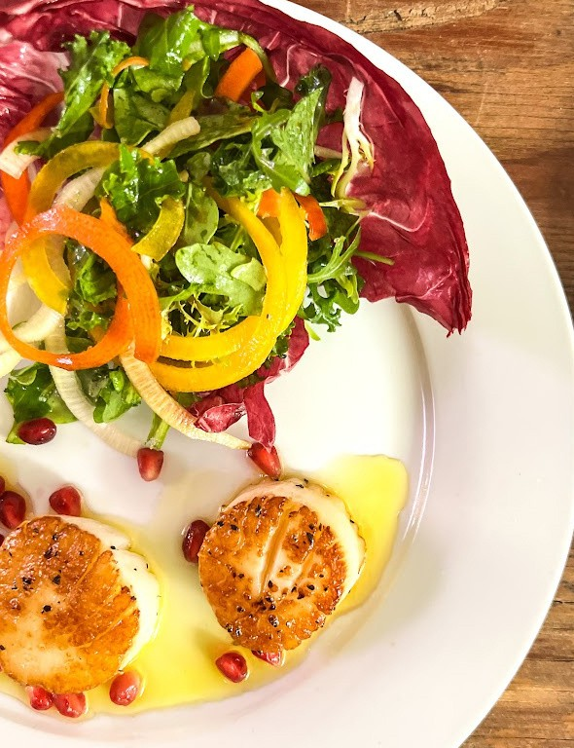

**I N F O @ P I G E O N C A T E R E R S . C O M ~ 5 0 4 - 2 6 2 - 0 4 1 2 ~**

**8 0 3 J E F F E R S O N H W Y . S U I T E 2 0 0 , J E F F E R S O N , L A 7 0 1 2 1 W W W . P I G E O N C A T E R E R S . C O M**

# PASSED HORS D' OEUVRES

VEGETARIAN OPTIONS MEAT OPTIONS SEAFOOD OPTIONS

##### CREOLE VEGETABLE JAMBALAYA ARANCINI(V)

*smoked paprika aioli*

##### BRANDY FLAMED MUSHROOM PHYLLO CUPS (V)

*with goat cheese*

##### CAPRESE SKEWERS (V,GF)

*with balsamic drizzle*

##### PETITE GRILLED CHEESE & TOMATO BASIL SOUP SHOOTER (V)

TEMPURA BATTERED ASPARAGUS (V)

*with garlic ginger & sweet soy sauce*

##### ARTICHOKE BISQUE (V)

*artichoke fritter*

##### SPINACH FENNEL PANCAKE (V)

*lemon ricotta, mango kiwi salsa*

##### RED BEAN SOUP SHOOTER (V, VG, GF)

*rice calaise*

##### APPLE CUCUMBER GAZPACHO VERDE(V, VG, GF)

*topped with a melon ball*

##### AVOCADO TOAST (V,VF)

*creole tomato jam, pepitas*

##### CRISPY CAULIFLOWER (V, VG)

*pecan romesco, micro cilantro*

##### ARTICHOKE BEIGNETS (V)

*lemon aioli*

##### CRISPY BOUDIN CAKE

*chow-chow*

##### APPLEWOOD BACON, GRUYERE & ONION TART

ALLIGATOR SAUSAGE EN CROUTE

*creole mustard, scallion*

##### CHARRED RARE BEEF BISCUIT

*torched rare beef, green onion spiced* biscuit, horseradish chive cream

##### CROQUE MADAME

*sourdough, chisesis ham, soubise, fried* quail egg

##### DUCK EMPANADAS

*with tabasco aioli*

##### DUCK LIVER MOUSSE CROSTINI

*balsamic cherry conserva, bacon, crostini*

##### GRILLED MEUNSTER, BRIOCHE, ANDOUILLE

*strawberry butter*

##### DUCK CONFIT

*sweet yam kettle chip, duck confit, fig* compote

##### CAJUN MEAT PIES

*with habanero aioli*

##### PETITE LAMB CHOPS| (GF)

*with garlic mint pesto*

##### SWEET POTATO BLINI, SHAVED TASSO

*fig butter*

##### SHRIMP, CRAB AND ROASTED CORN WON-TON

*tabasco pepper jelly*

##### SEARED SEA SCALLOP (GF)

*sweet potato and roasted pepper hash,* scallion butter

##### CRISPY FRIED OYSTER ROCKEFELLER

*tasso sabayon*

##### CRAWFISH BEIGNETS

*spicy Louisiana fritters with creolaise sauce*

##### CRABMEAT CHEESECAKE

*pecan crust, creole meuniere*

##### CRAB CAKE “CHOP”

*remoulade*

##### SEASONAL ASSORTED SEAFOOD CEVICHE SHOOTERS (GF)

SHRIMP & HERBED CREPE ROULADE

*with boursin cheese and creole tomato jam*

##### SHRIMP, SWEET POTATO HERB FRITTER (GF)

*chili lime aioli*

##### JUMBO LUMP GULF CRAB

*ravigote, savory cone*

##### YUKON GOLD GAUFRETTE (GF)

*black & gold caviar*

##### HOT SMOKED REDFISH CORN CAKES

*myer lemon aioli*

##### BBQ SHRIMP(GF)

*crispy cheddar grit cake, flash fried Lemon*

**V = V E G E T A R I A N , V E = V E G A N , G F = G L U T E N F R E E**

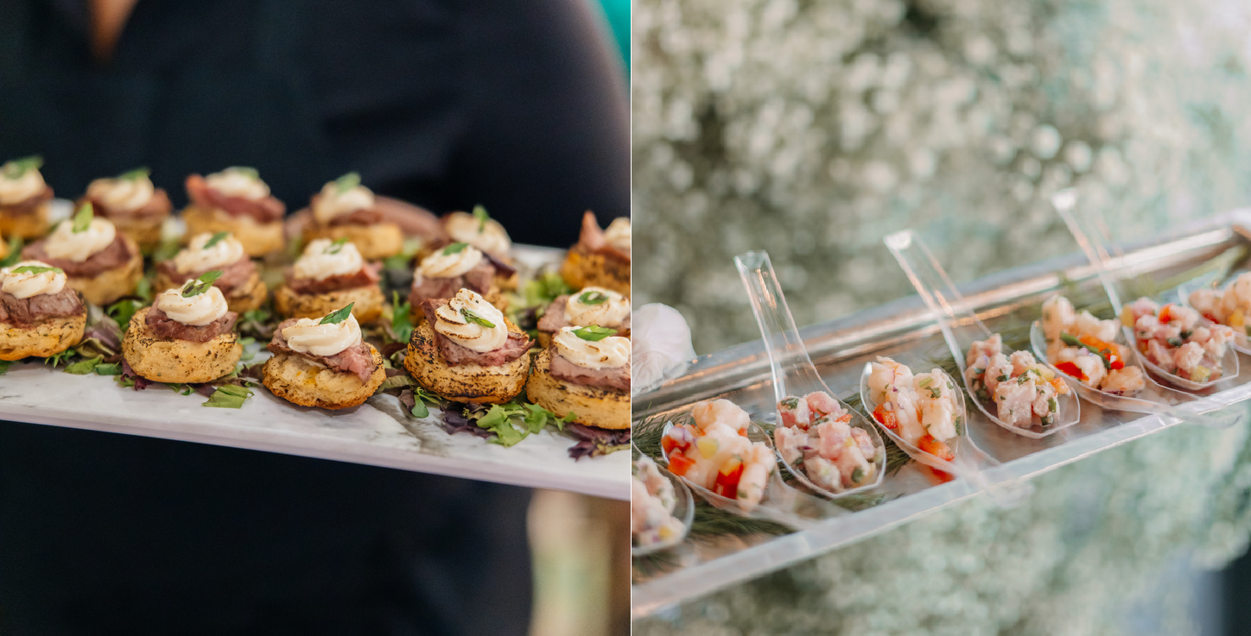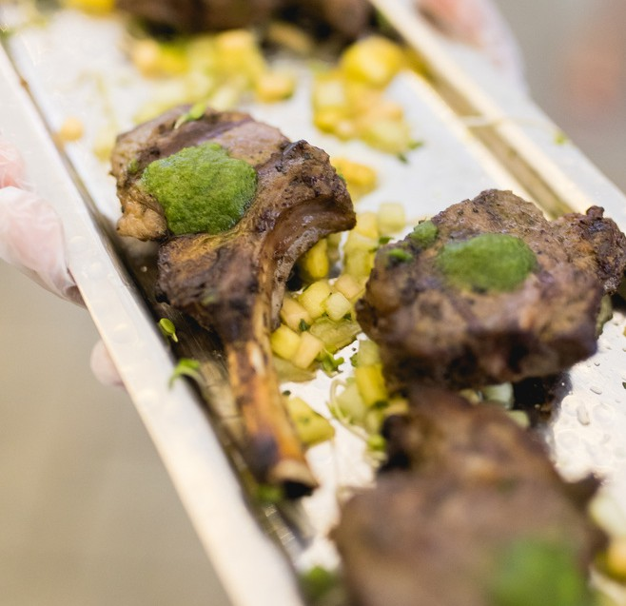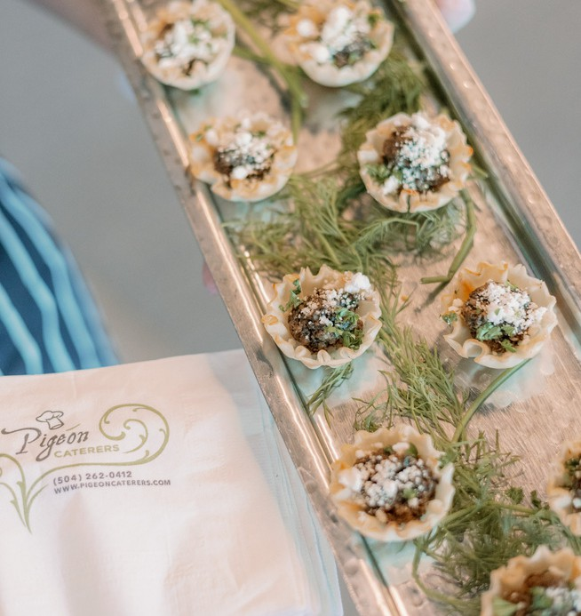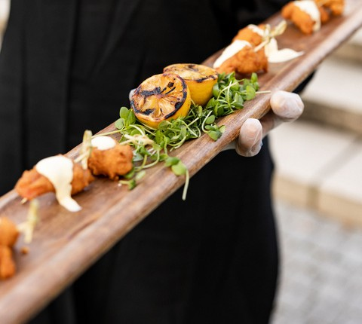

I N F O @ P I G E O N C A T E R E R S . C O M ~ 5 0 4 - 2 6 2 - 0 4 1 2 ~

8 0 3 J E F F E R S O N H W Y . S U I T E 2 0 0 , J E F F E R S O N , L A 7 0 1 2 1 W W W . P I G E O N C A T E R E R S . C O M

## APPETIZER DISPLAYS

**FRENCH CHEESES & SAVORY CHEESECAKES *DISPLAY V)***

*-Chef’s display of 5 French cheeses,* served with a variety of jams, mustards, pickled vegetables, breads and crackers

*-Savory Creole artichoke cheesecake*

*-Savory Blue cheese cheesecake with walnuts and dried apricots*

*-Savory Tuscany cheesecake with pine nuts and sundried tomato*

### CHOICE CHEESE & CHARCUTERIE DIPSLAY

*Chef’s selections of cheeses, cured Italian meats, nuts,*

*fresh fruit, cornichons, chutney, toasted bread & assorted mustards*

### DELUXE CHEESE & CHARCUTERIE DISPLAY

*Chef’s selections of French cheeses, assorted pâté , sausages* cured Italian meats, nuts, assortment of fresh fruits,, pickled vegetables,

*chutney, assorted mustards, assortment of toasted bread & crackers*

### DUO OF SOUPS

**CHOOSE 2**

**-Corn & Crab Bisque**

**-Mushroom & Brie *(V)***

**- Mock Turtle Soup**

**-Tomato Basil *(V)***

### MEDITERRANEAN HERB KABOBS *(GF)*

*chicken & beef kabobs, hummus, tomato,* mint & cucumber salad,

*Tzatziki sauce, Harissa chili sauce & Baba Ghanoush & Pita bread*

### SAVORY DIP STATION

*-Crabmeat Mornay (GF)*

*-Crawfish and Brie (GF)*

*-Spinach and Artichoke (V)*

*-Red Bean Hummus (VE, DF, GF)*

*with assorted pretzel bread sticks, tortilla chips,* toast points, garlic pita chips, broccoli and carrots

### NOLA BURRATA BAR

*Burrata cheese served with assorted toppings:* truffle oil, pesto, balsamic glaze, prosciutto,

*marinated gulf shrimp, marinated olives, Louisiana fig compote,* bruschetta, & pickled sweet peppers

*served with toasted breads and crackers*

### TASTE OF NEW ORLEANS

*-Mini Muffalettas,*

*-Boudin Balls,*

-*Spinach and Artichoke Dip (V)* Served with Cibaatta toast points

**V = V E G E T A R I A N , V E = V E G A N ,**

**G F = G L U T E N F R E E , D F = D A I R Y F R E E**

**V = V E G E T A R I A N , V E = V E G A N , G F = G L U T E N F R E E , D F = D A I R Y F R E E**

**I N F O @ P I G E O N C A T E R E R S . C O M ~ 5 0 4 - 2 6 2 - 0 4 1 2 ~**

**8 0 3 J E F F E R S O N H W Y . S U I T E 2 0 0 , J E F F E R S O N , L A 7 0 1 2 1 W W W . P I G E O N C A T E R E R S . C O M**

## SPECIALTY STATIONS

**CAULIFLOWER STEAK STATION *(V, VE,GF)***

*served with vegetable quinoa, sauteed garlic spinach* and ratatouille

### CHARGRILLED OYSTER BAR *(GF)*

**OPTION FOR 3 HOURS**

**OR JUST FOR COCKTAIL HOUR**

*Char-grilled oysters topped with our homemade* parmesan garlic butter sauce

*accompanied with lemons & French bread*

### FRIED CRAWFISH CAKES AND PAN SEARED CRAB CAKES STATION

*with pepper jelly vinaigrette* atop assorted baby greens

### CREOLE RICE BAR

**CHOOSE 3**

*Louisiana long grain rice, and French bread & butter* with Louisiana favorites for topping:

-*Cajun crawfish étouffée*

*-shrimp creole,*

*-red beans & smoked sausage or vegetarian red beans (V)*

*-chicken & andouille gumbo*

*-shrimp & okra gumbo*

*- gumbo Z'Herbs (V)*

### FRIED GREEN TOMATO STATION *(V)*

*cornmeal crusted fried green tomato slices,* sautéed lump crab meat with a lemon buerre blanc sauce,

*and fresh chopped bacon with creole aioli*

### GRITS STATION

*served with creamy cheddar grits (GF)* and topped with fresh chives

*served with New Orleans BBQ Shrimp and Ratatouille (V)*

Additional choices

*beef short ribs, grillades, or pulled pork*

### PASTA TWO WAYS :

**CHOOSE 2**

**-CAJUN PASTA**

*cream sauce, Louisiana spices, andouille sausage, gulf shrimp, peppers, mushroom with penne pasta*

**-CHEESE SACCHETTI & SUMMER TOMATOES *(V)***

*Shaved fennel, garlic chips, fresh basil and white wine over cheese filled tortellini*

**-CRAWFISH GERARD**

*crawfish, cream & basil, grated parmesan cheese, cracked black pepper, with penne pasta*

**-FARFALLE JAMBALAYA**

*grilled chicken & andouille sausage, gulf shrimp and spicy creole sauce with bow tie pasta*

**- SMOKED MUSROOM & RICOTTA RAVIOLI *(V)***

*buttered ricotta filled ravioli, smoked portabellas, button mushrooms, chives, chili flakes and shitake "chips" in a light cream sauce*

## SPECIALTY STATIONS CONTINUED

### PO-BOY STATION

*Made onsite and served with our Mardi Gras Slaw:* broccoli, carrots, purple cabbage, golden raisins, sunflower seeds,

*and bacon, tossed with a creamy slaw dressing*

*-fried shrimp, with lettuce, tomato and mayonnaise*

*-roast beef debris, with lettuce, tomato and mayonnaise*

**SEAFOOD BAR *(GF)***

**OPTION FOR 3 HOURS**

**OR JUST FOR COCKTAIL HOUR**

*Jumbo Gulf Shrimp, Seasonal Ceviche, & Marinated Blue Crab Claws* accompanied by our own Creole cocktail sauce,

*remoulade, and lemons.*

### SLIDER BAR

*Homemade Brioche Bun served with Herb Potato Salad*

*CHOOSE 2*

#### *-PAN ROASTED CRAB CAKE SLIDER*

*fried pickle chips, remoulade sauce*

#### *-CRISPY CATFISH SLIDER*

*mixed micro greens, smoked tomato tartar sauce*

#### *-CRISPY FRIED CHICKEN SLIDER*

*with Cajun aioli & bread n’ butter pickle*

#### *-MEATBALL SLIDER*

*with roasted peppers and marinara sauce*

### TIJUANA TACO STATION

*Choose 3 proteins:*

*-Braised Ancho Pork*

*-Taco al Carbon (char grilled sirloin steak)*

*-Ropa Vieja (spicy braised Cuban beef brisket)*

*-Chipotle grilled chicken breast*

*-Tequila Shrimp*

*-Picadillo (Cuban spicy ground beef)*

*-Seasonal Grilled Vegetables. served with corn and flour tortillas, guacamole, salsa, limes, radishes,*

*Latin cheeses, shredded lettuce, cilantro & jalapeños*

## CARVING STATIONS

all served with soft rolls and condiments

### BONELESS ROASTED TURKEY BREAST *(GF)*

*with creole marmalade glaze*

### BOUDIN STUFFED PORK LOIN

*wrapped in applewood bacon, with* Creole mustard Madeira jus

### SMOKED PRIME RIB *(GF)*

*with mushroom au jus and horseradish cream & cooked medium rare*

### TABASCO RUBBED PORK TENDERLOIN *(GF)*

*with creole mustard au jus*

### TOP ROUND OF BEEF *(GF)*

*garlic stuffed and wood roasted*

*served with an herb au jus and cooked medium rare*

### BEEF TENDERLOIN *(GF)*

*with cabernet sauvignon au jus and cooked medium rare*

## SIDE DISH

**CAESAR SALAD (V) CELEBRATION SALAD (V) CORN MACQUE CHOUX (V)**

**GARLIC MASHED POTATOES (GF)**

**MAPLE MASHED SWEET POTATOES (GF) SCALLOPED POTATOES (V)**

**SEASONAL GRILLED VEGETABLES (V, VE, GF, DF) SMOKED GOUDA MASHED POTATOES (GF) SPINACH MADELEINE (V, GF)**

**STONE GROUND CHEESE GRITS (V, GF) WILD MUSHROOM RISOTTO (V)**

**V = V E G E T A R I A N , V E = V E G A N , G F = G L U T E N F R E E , D F = D A I R Y F R E E**

**I N F O @ P I G E O N C A T E R E R S . C O M ~ 5 0 4 - 2 6 2 - 0 4 1 2 ~**

**8 0 3 J E F F E R S O N H W Y . S U I T E 2 0 0 , J E F F E R S O N , L A 7 0 1 2 1 W W W . P I G E O N C A T E R E R S . C O M**

# MENU COLLECTION ENHANCEMENTS

## DESSERTS

### PETITE DESSERTS DISPLAY

Assortment of Cakes, Cheesecakes, Cookies, Brownies, Lemon Squares

### ICE CREAM SANDWICH STATION

an assortment of House Baked Cookies, Vanilla Bean Ice Cream, Chocolate Fudge Sauce, White Chocolate Sauce, Marinated Berries & Whipped Chantilly Cream

### BANANAS FOSTER STATION

fresh bananas sautéed onsite with cinnamon, brown sugar, banana liquor & 151 Proof Rum

served over Vanilla Bean Ice Cream

### NEW ORLEANS STYLE BREAD PUDDING STATION

Served with assorted sauces for your guests to choose from praline sauce, whiskey sauce, and white chocolate.

### KING CAKE DISPLAY

Traditional, Cream Cheese & Chef's Choice Filling King Cakes

## LATE NIGHT PASSED SNACKS

*Passed to your guests the last 30 minutes of the reception select from the following:*

### MINI BEIGNETS AND CAFÉ AU LAIT SHOOTERS

*passed fresh fried beignets* served with café au lait

### MINI TACOS

*Choice of pulled pork or Tequila Shrimp with Mango Salsa*

### CHICKEN TENDERS

*choice of Ranch dressing or BBQ sauce or Fulton Sauce*

### FRENCH FRIES IN A CONE *(V)*

*choice of ketchup, remoulade or garlic aioli*

### TRADITIONAL BEEF SLIDERS & FRIES

*with bread & butter pickles*

### MINI CORNDOGS

*Yellow Mustard*

**I N F O @ P I G E O N C A T E R E R S . C O M ~ 5 0 4 - 2 6 2 - 0 4 1 2 ~**

**8 0 3 J E F F E R S O N H W Y . S U I T E 2 0 0 , J E F F E R S O N , L A 7 0 1 2 1 W W W . P I G E O N C A T E R E R S . C O M**

## SPECIAL MEAL

**KID’S MEALS**

**(For Guests under 12)**

## Chicken Tenders | Mac n’ Cheese Cheeseburger |Mac n’ Cheese Mac n’ Cheese| Fruit Cup

**VENDOR MEALS**

*ilfl071*

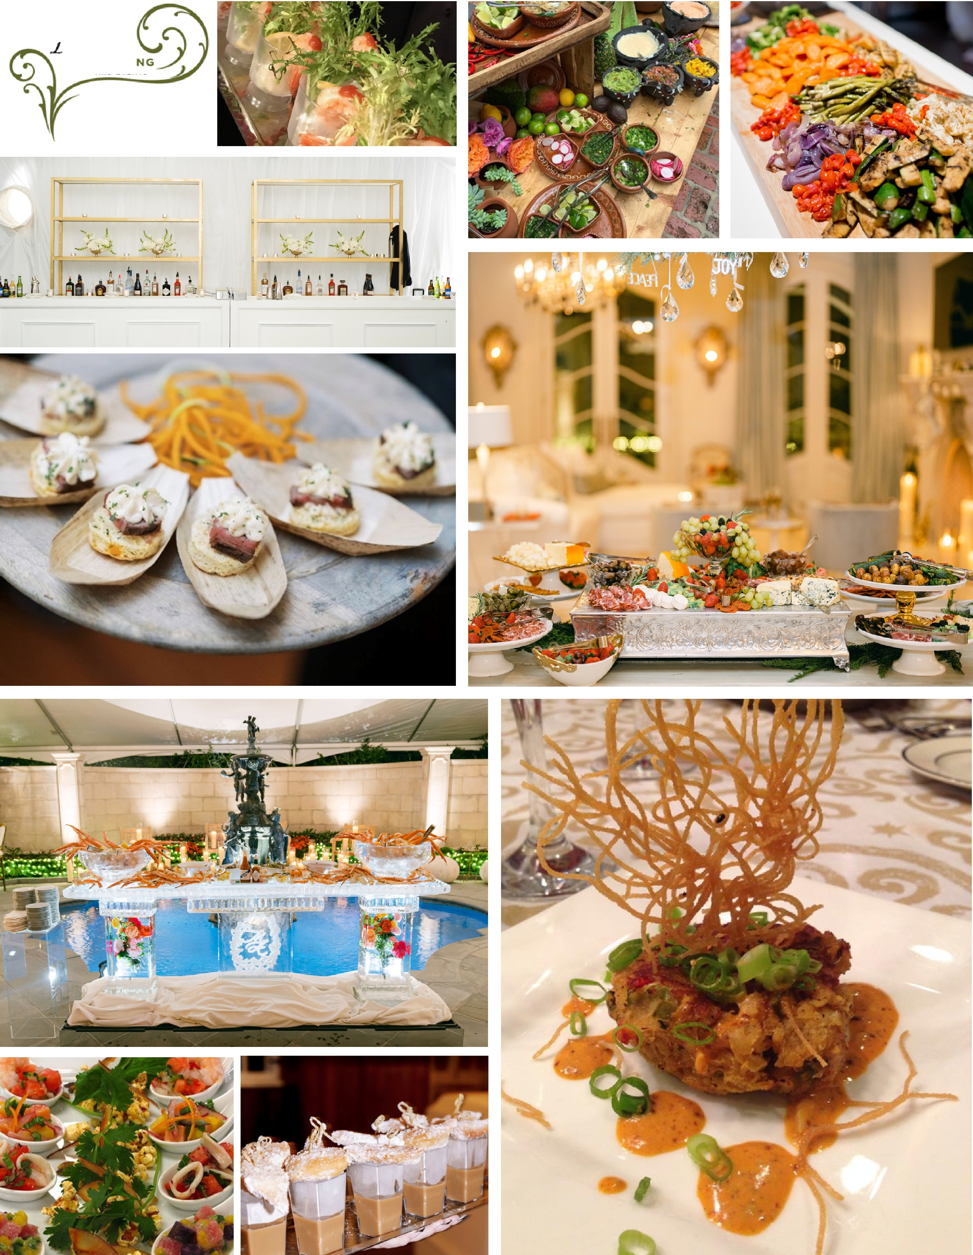

**tl'cATERI**

.a.NICO EVENTS