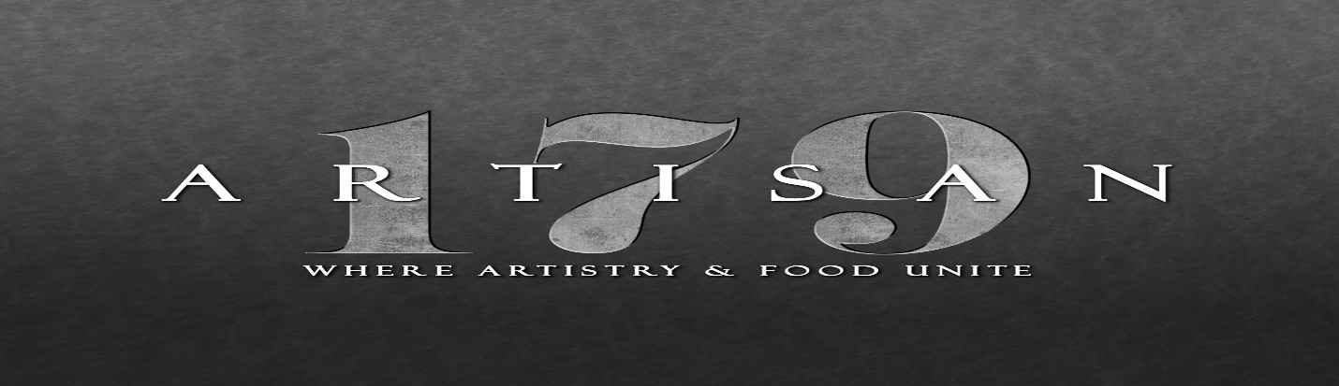

**RHINO ROOM**

**CALL/RAIL-** $7-$9

Titos, Grey Goose, Ketel One, Smirnoff, Stoli, Tanqueray, Seagram’s, Southern Comfort, Canadian Club, Crown Royal, Jameson, Jack Daniels, Maker’s Mark, Jim Beam, Korbel, Bacardi, Captain Morgan & Many More Available

**MID-TEIR-** $9-$12

Bulliet, Casamigos, Patron, Don Julio, Blanco, Belvedere, Chopin, Hendricks, Gray Whale, Uncle Vals, Bombay, Dewars & Many More Available

We Do Have Higher End Spirits On The Shelves That Widely Range In PriceIf A Fully Open Bar Is Offered

**RHINO ROOM HOUSE WINES-** THE BRAND VARIES FOR EACH VARIETAL

**REDS AVAILABLE** $14 Per Glass- Cabernet Sauvignon, Pinot Noir, Malbec, Red Blend, Zinfandel. Merlot

**WHITES AVAILABLE** $12 Per Glass- Prosecco, Rosé, Chardonnay, Pinot Grigio, Sauvignon Blanc (New Zealand), Moscato, Riesling

**BEER VARIETY**

$4.75-$7

**CRAFT COCKTAILS OFFERED FROM THE REGULAR MENU**

RON & MARY’S BROWN MUMBLER $15

HOUSE AGED BULLEIT RYE BOURBON, FRESH ORGANIC ORANGE, LUXARDO CHERRY, BROWN SUGAR CUBE, BITTERS, SWEET SODA **Sub Korbel brandy if preferred

BLOOD ORANGE MANHATTAN $15

HOUSE AGED BULLEIT RYE BOURBON, SWEET VERMOUTH, BLOOD ORANGE SIMPLE SYRUP, LUXARDO CHERRY

HIBISCUS MARGARITA $15

CAZADORES BLANCO TEQUILA, ORGANIC LEMON JUICE, HIBISCUS HONEY SIMPLE SYRUP, TRIPLE SEC, SWEET AND SOUR, CAYENNE SUGAR RIM

FIFTY SHADES OF GREY GOOSE $15

GREY GOOSE VODKA, FILTHY OLIVE BRINE, DRY VERMOUTH, HOOKS BLUE CHEESE OLIVES, SERVED UP

BRONX TALE $15

TANQUERAY SEVILLA ORANGE GIN, TRIPLE SEC, GRAND MARNIER, ORGANIC LEMON JUICE, SERVED UP, SUGAR RIM

THREE HOUR TOUR $15

RUMCHATA, VAN GOGH VANILLA VODKA, KAHLUA, BISCOTTI LIQUEUR, HEAVY CREAM

Many Other Cocktails Are Available That Range From $10- $15