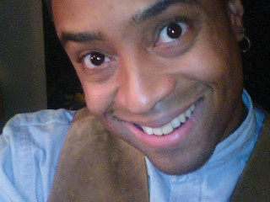
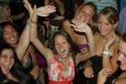
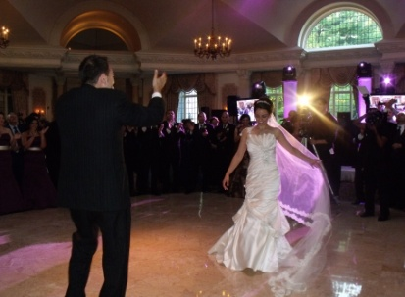
JVE Entertainment Partners
Randy Jenkins
Owner Operator – Managing Partner
DJ Entertainer / Emcee

“We need to start by first saying YOU ROCK!! The more wedding receptions we attend, the more we realize how awesome you truly are. You made our reception an overwhelming success that is still brought up in conversations these many years later. It was truly amazing. Thank you so much for everything that day and all that you did leading up to it. Bravo!

“We just want to thank you for an amazing job you guys did for our daughter’s Sweet 16. We're still talking about it and how you made Christina feel like a princess on her night. We were so impressed on how you made the experience so perfect with amazing music, dancing and interaction with ALL of our guests all through the night. This is a great memory that will last a lifetime for all of us. Thank you so much for making her night so special!”

“Our DJs provided just the right mix of music and entertainment for our event, challenging our guests with trivia, keeping the event lively the entire time, and I dare say having as much fun with us as we had with them. Truly the most professional and accommodating pair to work with, I personally have ever experienced.”
JVE Entertainment Partners
Plainfield, New Jersey
07060

(908) 405-4024

rjhoo84@yahoo.com
info@jve-ent.com

(908) 405-4024

rjhoo84@yahoo.com
info@jve-ent
Your Party, Your Way
GUARANTEED!

Professional DJs, Emcees and Special Event Services
What Can We
Do for You
Visit us on the web at www.jve-ent.com
Or call us today for questions, further information or a FREE no-obligation consultation regarding your event!
(908) 405-4024
Be sure to ask about......
- Our customer appreciation and rewards program
- Customer referral plan
- Balloons or Bouquet..?
- Our Volunteer and Community outreach efforts
- Discounts and more..!

- NO DEPOSITS required
( for most events)

- FULLY INSURED as required by many of New Jersey’s finest venues

- MEMBER of multiple national and local entertainment organizations and associations including The New Jersey Disc Jockey Network (NJDJN) and The National Association of Mobile Entertainers (N.A.M.E.)

Your Party, Your way
GUARANTEED!
Who We Are
With over 30 years combined experience, in the Mobile DJ and Special Event industries, JVE Entertainment Partners has been providing personalized musical entertainment services throughout the tri state area to hundreds of satisfied customers.
- Weddings
- Sweet Sixteens
- Bar/Bat Mitzvahs
- Quincineras
- Birthdays
- Communion Celebrations
- Children’s Parties
- Corporate and Community
Events
- Proms and School Events
- Promotions and Openings
- Karaoke
- Gameshow and Trivia Hosting
and more.....

Playing music for all occasions, offering distinctive specialties in Wedding Receptions, and always delivering outstanding Customer Service, is what sets us apart from the larger entertainment companies, most only interested in the “quantity” of parties and not the “quality” of the service they provide. JVE sets the NEW standard in quality customer and entertainment services.

Who are JVE Entertainment Partners?
With a vast myriad of DJ Entertainment companies to choose from throughout the Tri-State area...Why select our company? What sets us apart from all others in the industry?
Put simply...it is our unique approach to the business. Your event, for us, as it is for you, is very personal and should be treated and respected as such. This is immediately evident from our first hello to the last goodbye at the end of your event.
Our mission is to consistently provide our clients and their guests, not only with high quality music and entertainment, but with the most comfortable and rewarding customer service experience possible. For this is truly about you, the customer, not us.
Professionalism, Experience, Fun, Excitement, Energy; are all qualities that you will immediately find, and ultimately experience when choosing JVE Entertainment Partners.

