DJ Entertainer Randy Jenkins Bio:

From an early age, Randy felt the burning desire to perform and entertain. Now, after 30 years in the entertainment & creative industries, Randy brings an incredible variety of experience to your celebration. His resume highlights his career as an actor in theater, commercials, television and films, an experienced theatrical technician and designer, special events producer, artistic director, and over 30 years as an exciting DJ Entertainer and Emcee with some of New Jersey’s most recognized entertainment companies. For over a decade, he co-owned and operated a successful technical theater production company, and has worked as a Special Event Producer, Designer and Decorator with several large Special Event Production companies. With a dynamic, incredibly articulate vocal style, vast range of music knowledge, energetic presence and his amazing dance moves on the dance floor, Randy is a uniquely versatile and talented performer who always leaves a great impression!
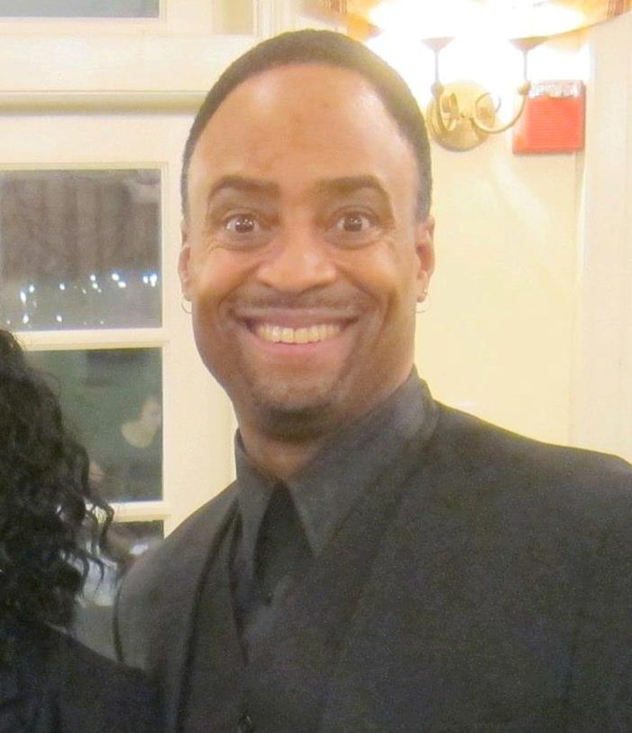
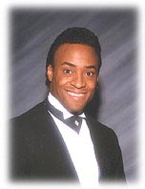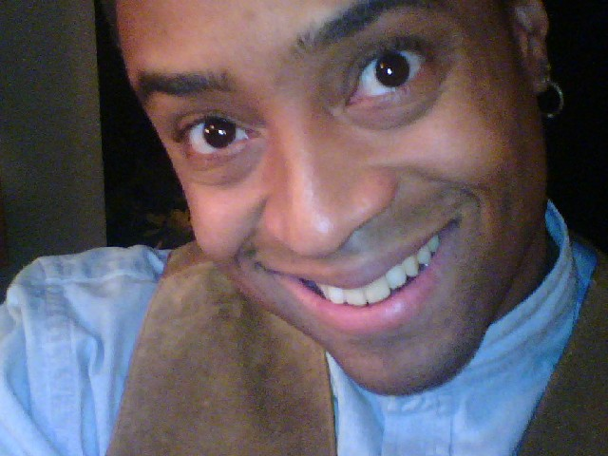

“I have provided music and emcee entertainment for countless events ranging from Weddings, Bar/Bat Mitzvahs, Sweet 16’s, Proms/School functions, Anniversaries, Children’s Parties, Corporate / Promotional events, and more. Not just a DJ/Emcee, my experience and services include Event Planning and Coordinating, Decorating (custom theme décor and props) and enhanced Lighting and Sound System design; my experience sets me apart from other DJ Entertainers. My passion for my work comes from my love of music and entertainment, meeting people of diverse backgrounds, and participating with people as they have fun on the dance floor. I have been called “the life of the party”, because of the energy I bring to every event. My PROFESSIONAL and COURTEOUS approach begins from my first contact with you, and shines through every moment of your event, being careful to NEVER overshadow your special day, as many other DJ’s make the mistake of doing. My promise to you is that I will assist you in any and every way, from complimentary lighting packages, discounts to accommodate your budget, even meeting with you at no extra charge; all to create an exciting event experience for you and your guests. Through my versatility, diverse music knowledge and style, professionalism and charisma….your event, will truly be one to remember.” That is my promise to you.

